2.COMPRESSED AIR TREATMENT UNITS:
https://www.prevost.eu/compressed-air-treatment-units-1825
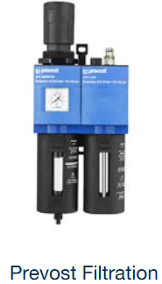
https://www.prevost.eu/compressed-air-treatment-units/prevost-filtration-3661
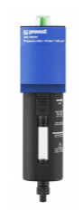
https://www.prevost.eu/filter-3633
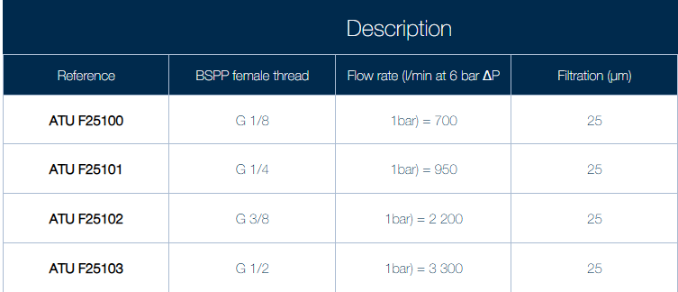

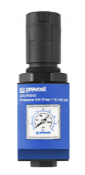
https://www.prevost.eu/regulator-3637
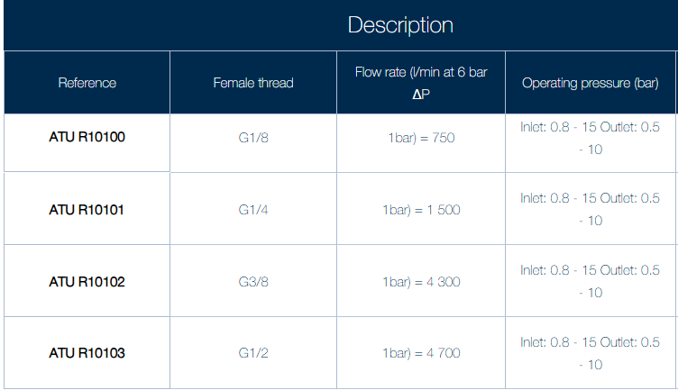

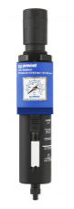
https://www.prevost.eu/filter-regulator-3634
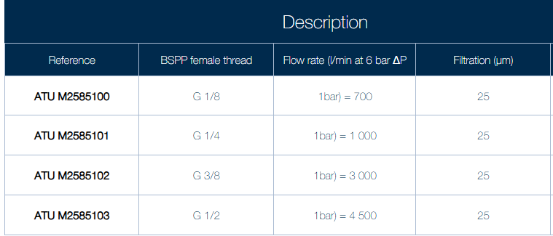

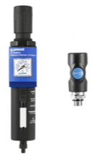
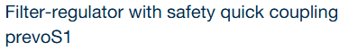
https://www.prevost.eu/filter-regulator-safety-quick-coupling-prevos1-3635
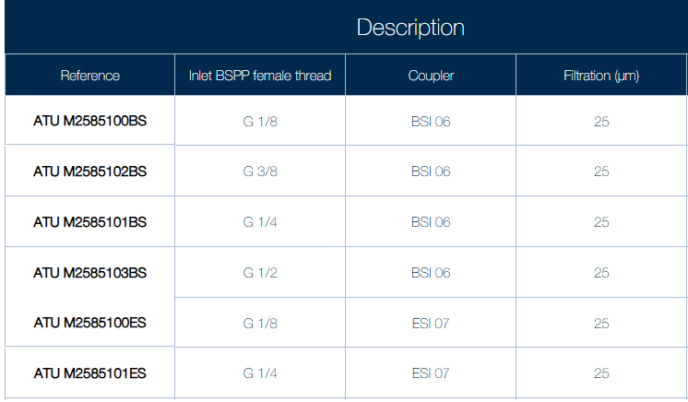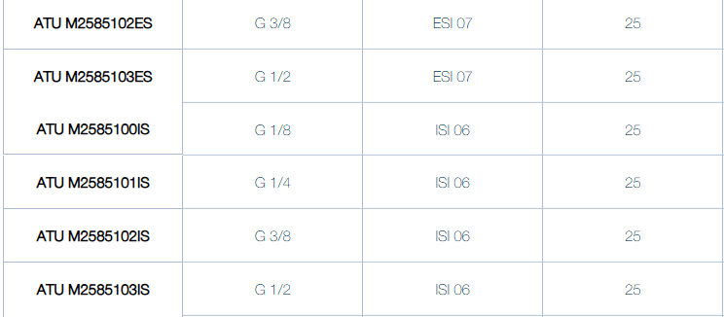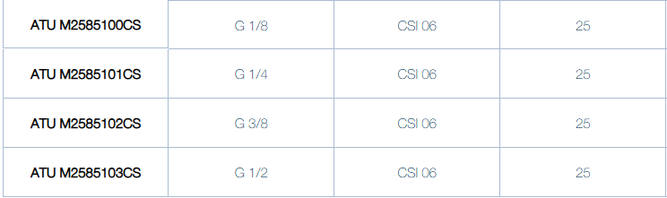
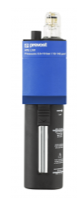
https://www.prevost.eu/lubricator-3636
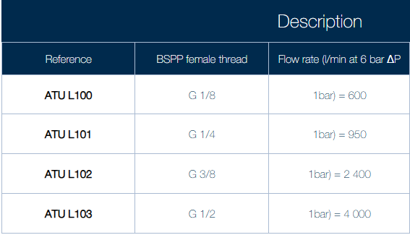

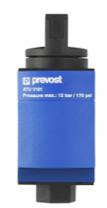
https://www.prevost.eu/manually-operated-pressure-relief-valve-3640
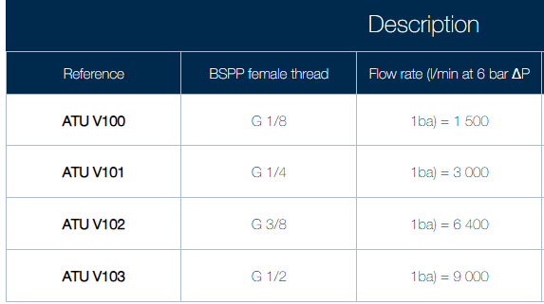

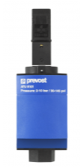
https://www.prevost.eu/electrically-operated-pressure-relief-valve-3641
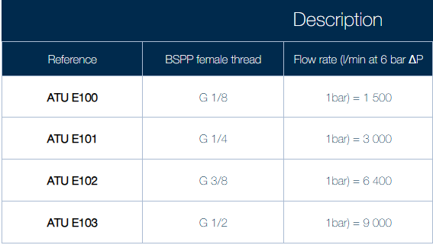

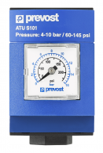
https://www.prevost.eu/progressive-pressurization-valve-3639
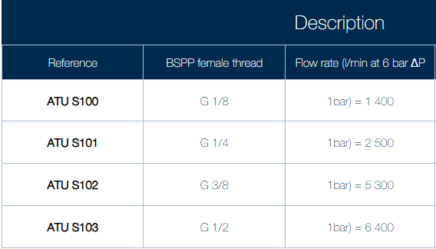

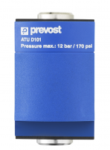
https://www.prevost.eu/splitter-3-outputs-3638
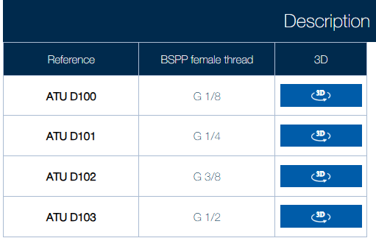

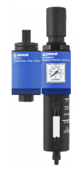
https://www.prevost.eu/filter-regulator-manual-valve-2-units-3648
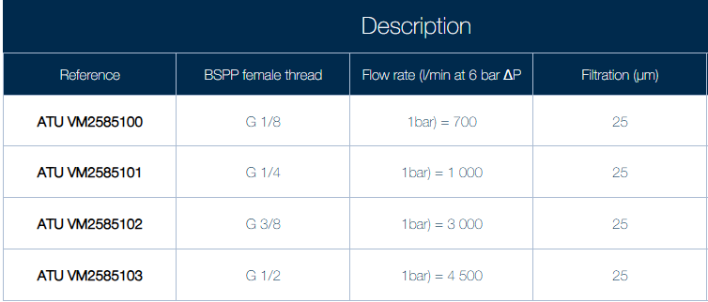

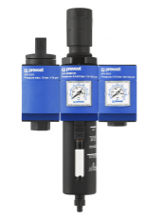
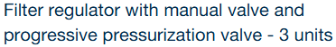
https://www.prevost.eu/filter-regulator-manual-valve-and-progressive-pressurization-valve-3-units-3649
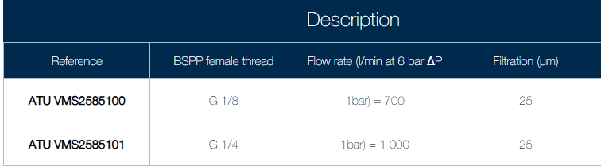

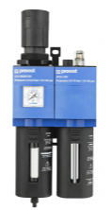
https://www.prevost.eu/filter-regulator-lubricator-2-units-3643
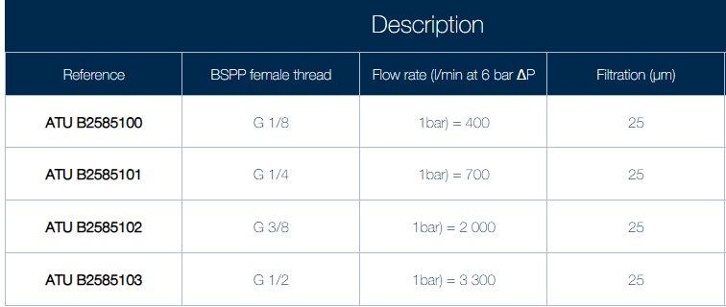

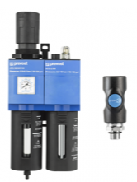
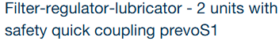
https://www.prevost.eu/filter-regulator-lubricator-2-units-safety-quick-coupling-prevos1-3644
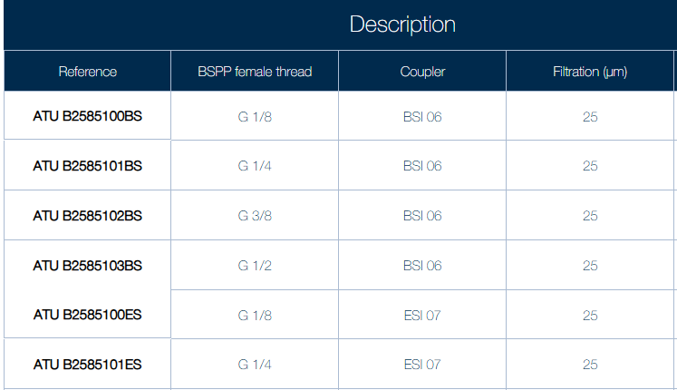
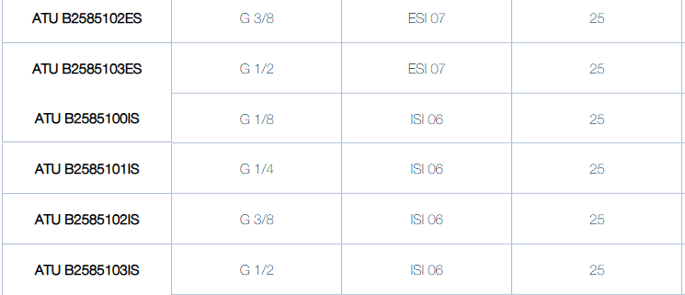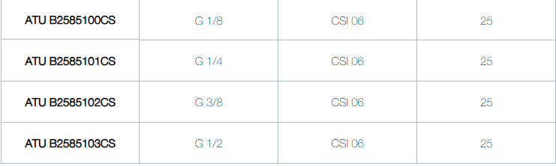

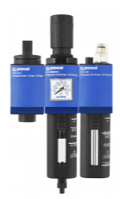
https://www.prevost.eu/filter-regulator-manual-valve-3-units-3647
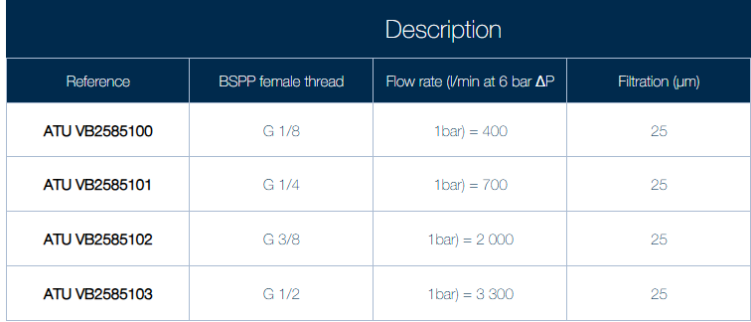

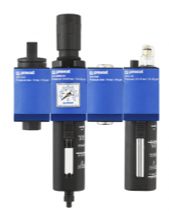
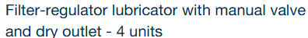
https://www.prevost.eu/filter-regulator-lubricator-manual-valve-and-dry-outlet-4-units-3645
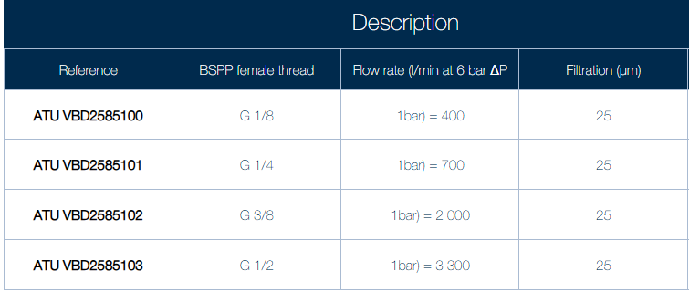

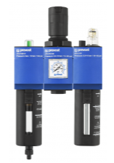
https://www.prevost.eu/lubricator-filter-regulator-3-units-3646-4
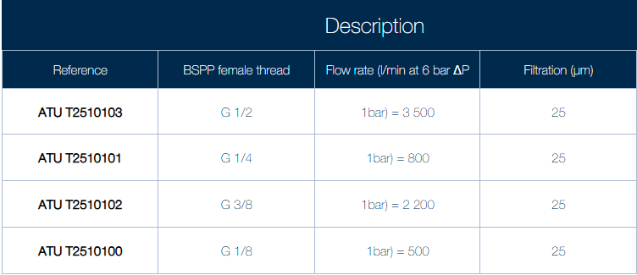
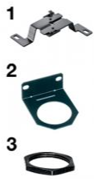
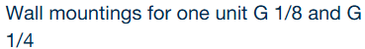
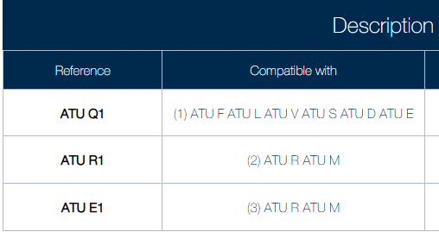
https://www.prevost.eu/wall-mountings-one-unit-g-1-8-and-g-1-4-3655
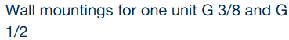
https://www.prevost.eu/wall-mountings-one-unit-g-3-8-and-g-1-2-3656
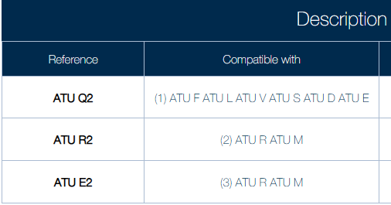
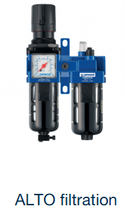
https://www.prevost.eu/compressed-air-treatment-units/alto-filtration-1838
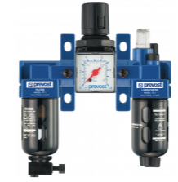
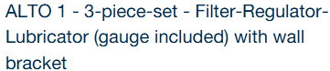
https://www.prevost.eu/alto-1-3-piece-set-filter-regulator-lubricator-gauge-included-wall-bracket-173
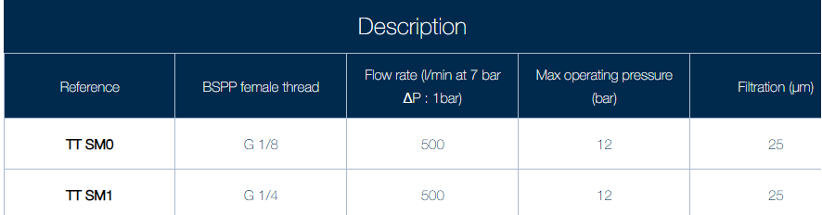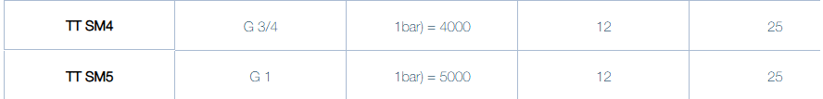

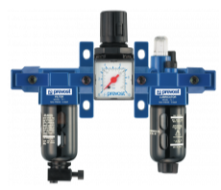
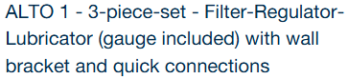
https://www.prevost.eu/alto-1-3-piece-set-filter-regulator-lubricator-gauge-included-wall-bracket-and-quick-connections
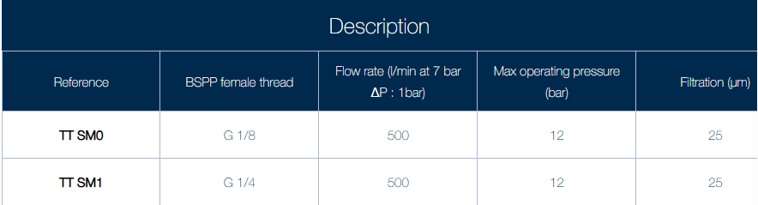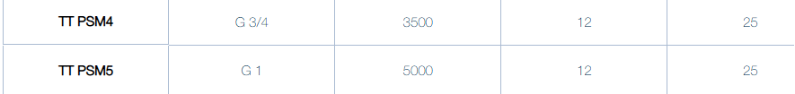

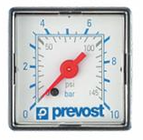
https://www.prevost.eu/compressed-air-treatment-units/gauges-compressed-air-3663
https://www.prevost.eu/product/2143
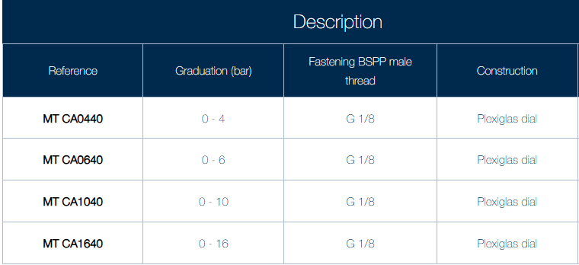

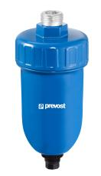
https://www.prevost.eu/automatic-mechanical-drain-valve-881
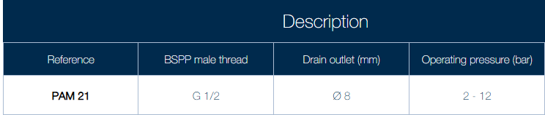

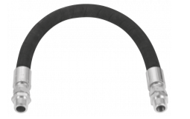
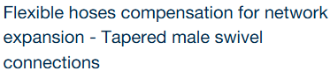
https://www.prevost.eu/flexible-hoses-compensation-network-expansion-tapered-male-swivel-connections-1577
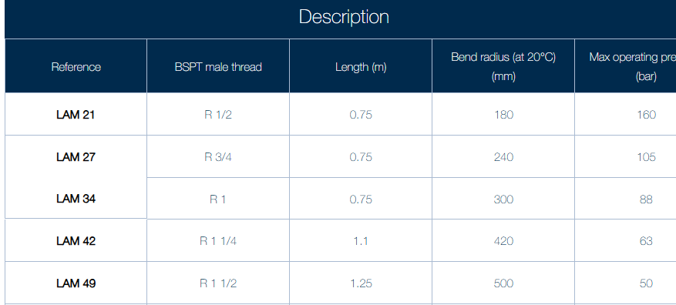

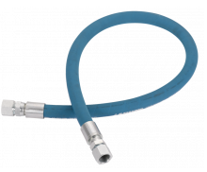
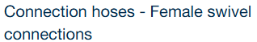
https://www.prevost.eu/connection-hoses-female-swivel-connections-992
