1.CONNECTION:
https://www.prevost.eu/connection-1823


https://www.prevost.eu/connection/quick-couplings-and-adaptors-compressed-air-2
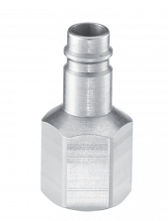
https://www.prevost.eu/female-thread-adaptor-2412
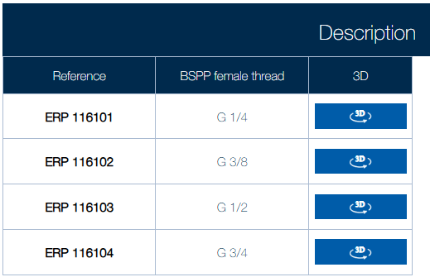
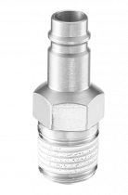
https://www.prevost.eu/male-thread-adaptor-2413
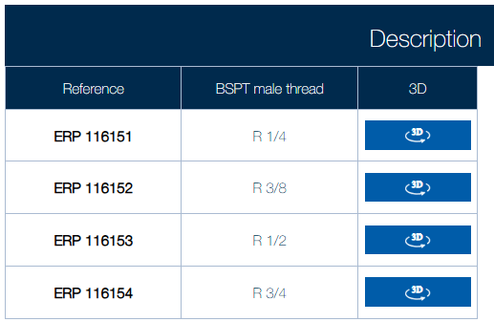
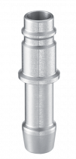
https://www.prevost.eu/hose-tail-adaptor-2414
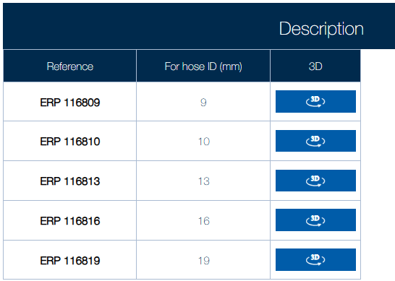
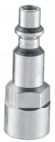
https://www.prevost.eu/parallel-female-thread-adaptor-243
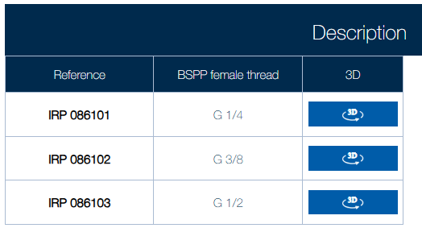
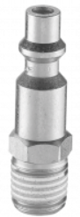
https://www.prevost.eu/tapered-male-thread-adaptor-244
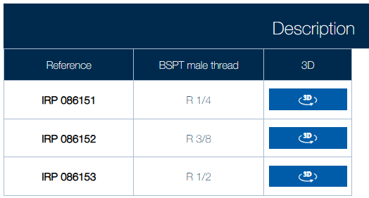

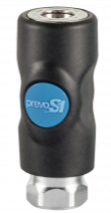
https://www.prevost.eu/parallel-female-thread-coupler-1843
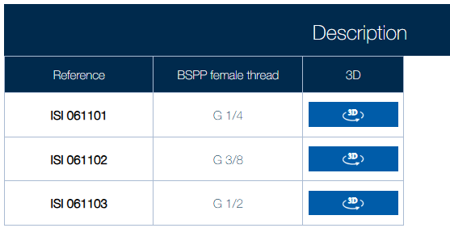

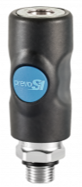
https://www.prevost.eu/parallel-male-thread-coupler-1844
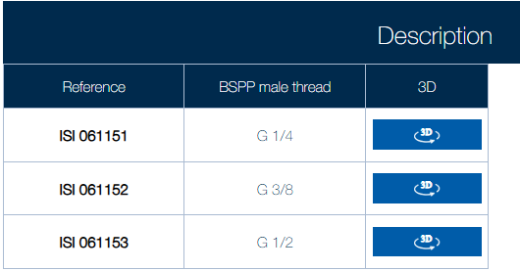

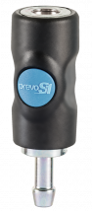
https://www.prevost.eu/hose-tail-coupler-1845
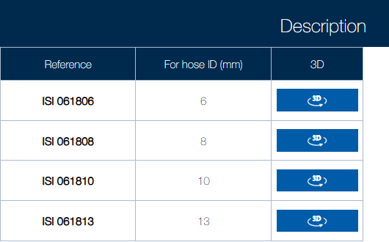

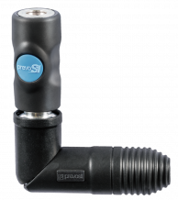
https://www.prevost.eu/thread-swivel-coupler-1842
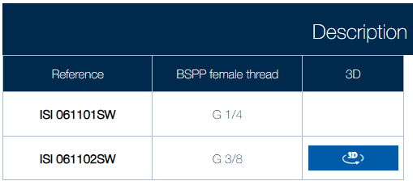

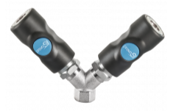
https://www.prevost.eu/parallel-female-thread-twin-coupler-1847
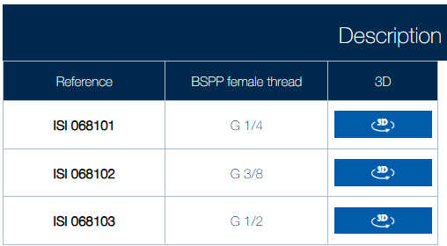

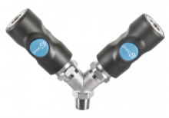
https://www.prevost.eu/tapered-parallel-male-thread-twin-coupler-1848
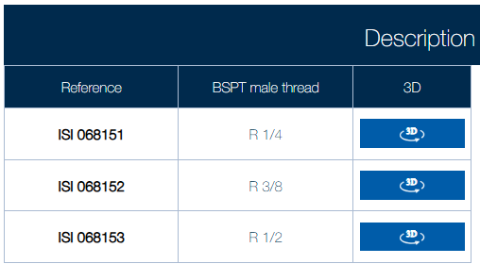

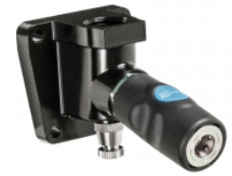
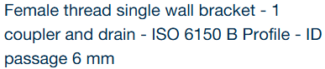
https://www.prevost.eu/female-thread-single-wall-bracket-1-coupler-and-drain-iso-6150-b-profile-id-passage-6-mm-2611

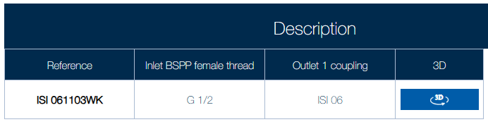

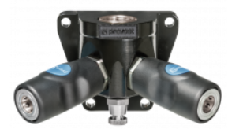
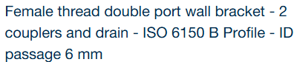
https://www.prevost.eu/female-thread-double-port-wall-bracket-2-couplers-and-drain-iso-6150-b-profile-id-passage-6-mm-2389
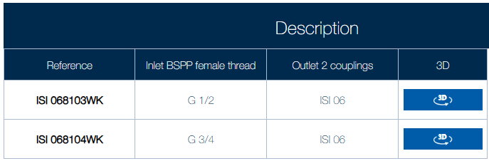

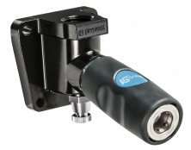
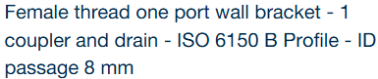
https://www.prevost.eu/female-thread-one-port-wall-bracket-1-coupler-and-drain-iso-6150-b-profile-id-passage-8-mm-2612

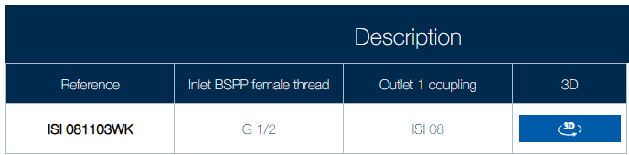

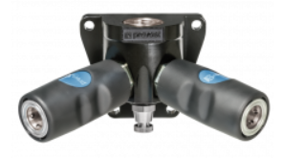
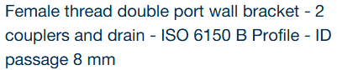
https://www.prevost.eu/female-thread-double-port-wall-bracket-2-couplers-and-drain-iso-6150-b-profile-id-passage-8-mm-2390

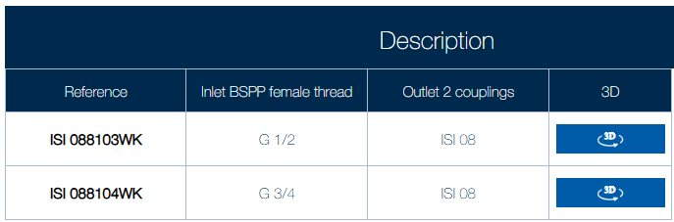

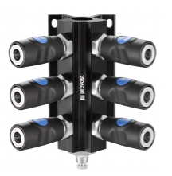
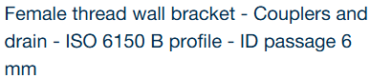
https://www.prevost.eu/female-thread-wall-bracket-couplers-and-drain-iso-6150-b-profile-id-passage-6-mm-3445
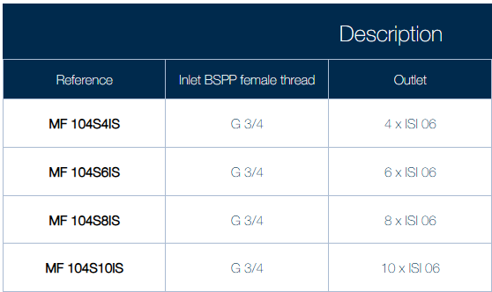

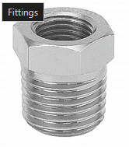

https://www.prevost.eu/connection/fittings-1827
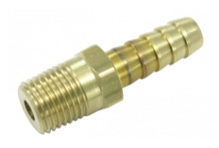
https://www.prevost.eu/tapered-male-thread-hose-tail-jft-490
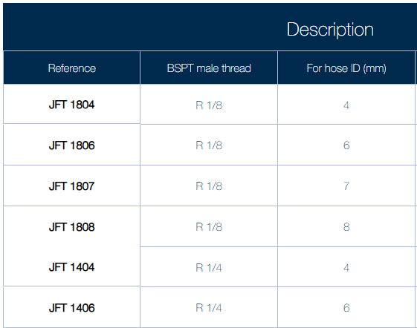
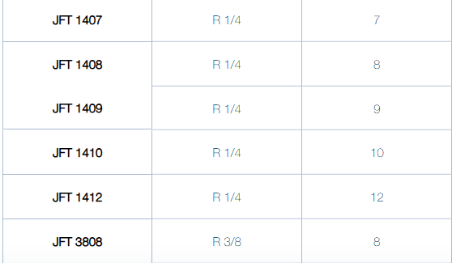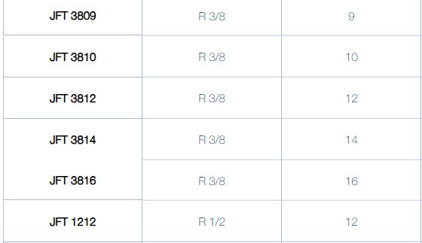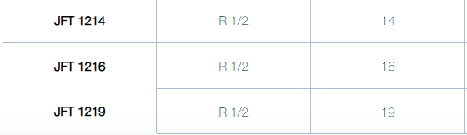
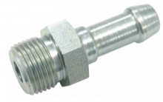
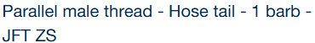
https://www.prevost.eu/parallel-male-thread-hose-tail-1-barb-jft-zs-491
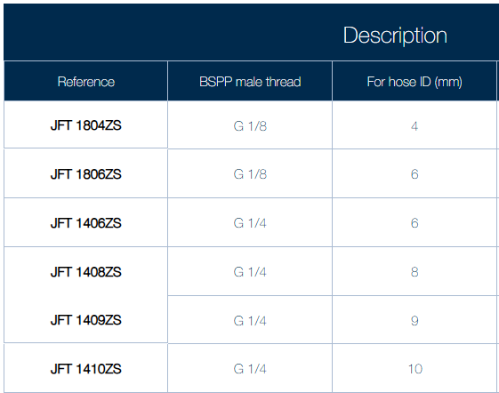
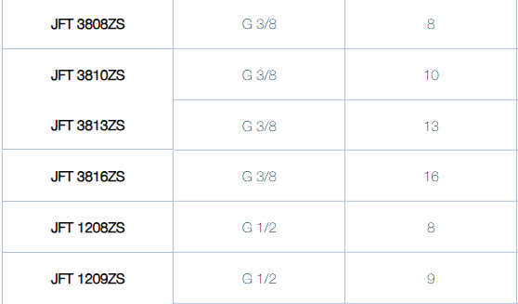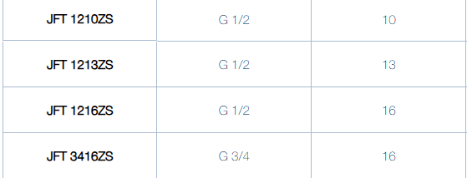

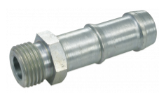
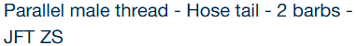
https://www.prevost.eu/parallel-male-thread-hose-tail-2-barbs-jft-zs-1123
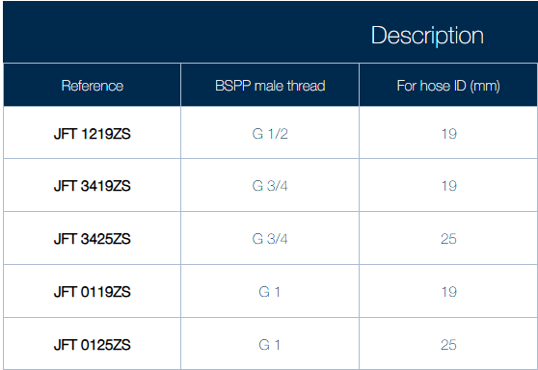

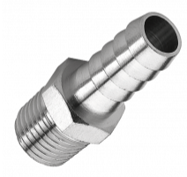
https://www.prevost.eu/tapered-male-thread-hose-tail-jpc-492
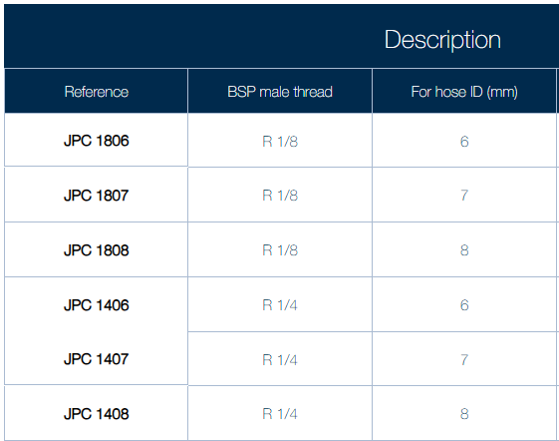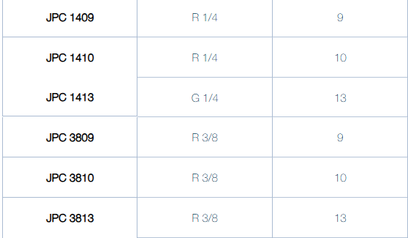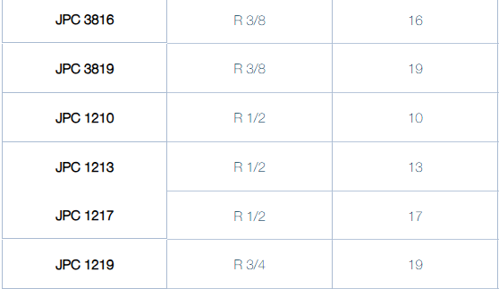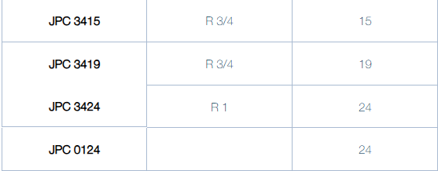
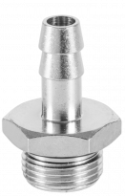

https://www.prevost.eu/parallel-male-thread-hose-tail-seal-jmj-493
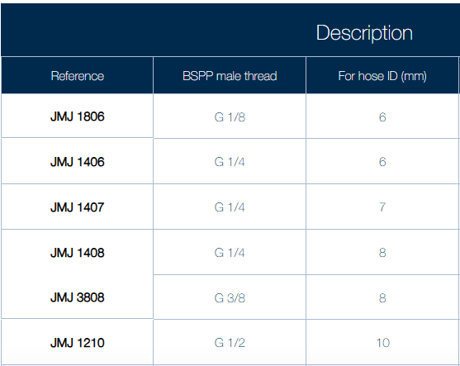

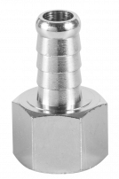
https://www.prevost.eu/parallel-female-thread-hose-tail-jftf-494
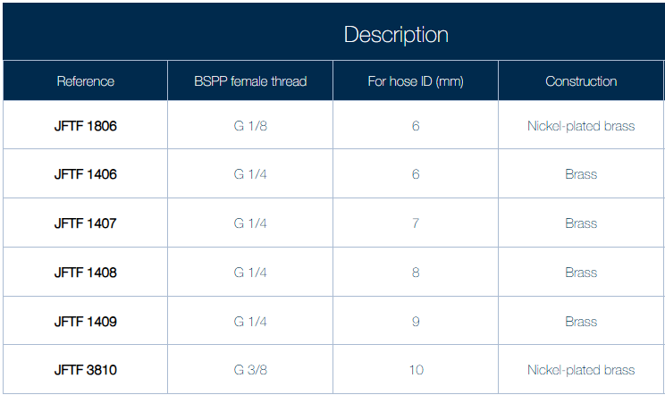

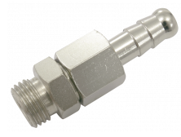
https://www.prevost.eu/parallel-male-thread-swivel-hose-tail-jfo-495
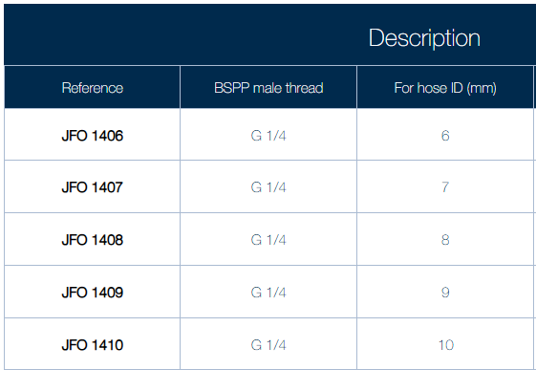
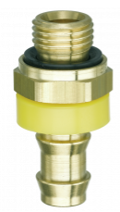
https://www.prevost.eu/push-hose-tail-male-thread-af-1275
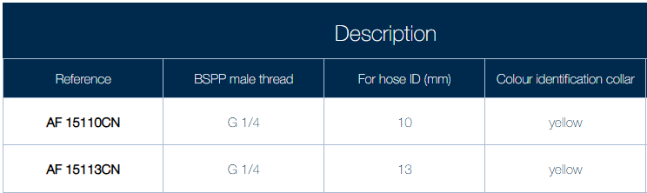
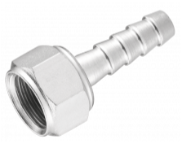
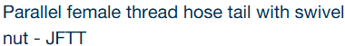
https://www.prevost.eu/parallel-female-thread-hose-tail-swivel-nut-jftt-496
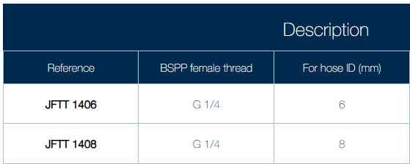

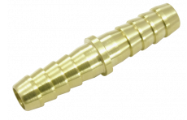
https://www.prevost.eu/hose-joiner-jdt-497
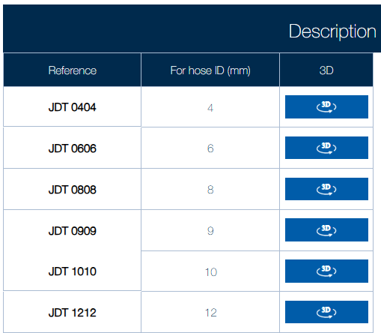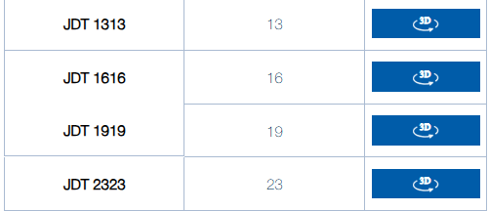

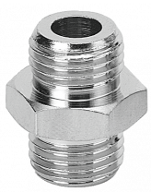
https://www.prevost.eu/parallel-male-union-a1-498
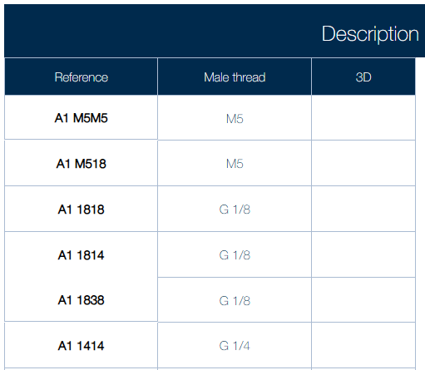
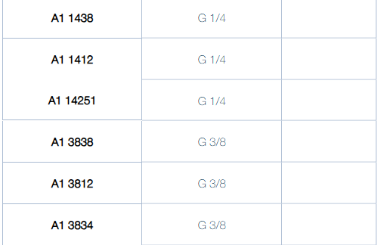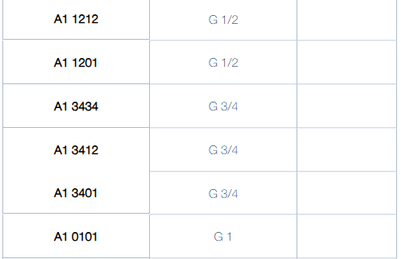

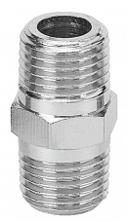
https://www.prevost.eu/tapered-male-union-a2-499
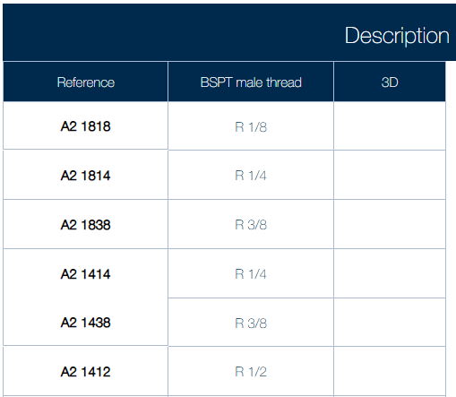
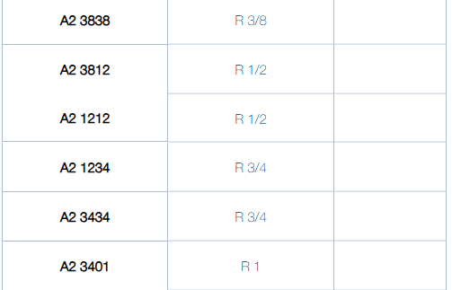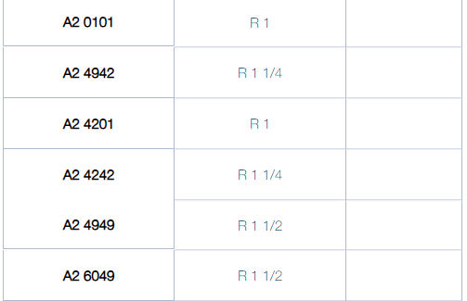

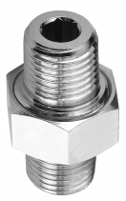
https://www.prevost.eu/rotating-3-piece-tapered-male-union-a2t-500
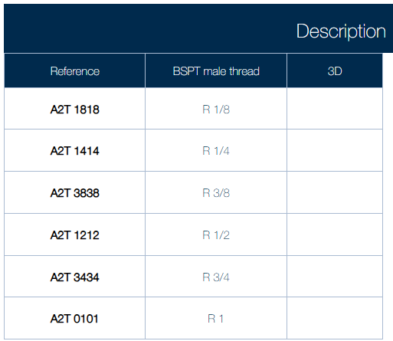

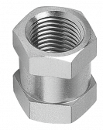
https://www.prevost.eu/equal-socket-a3-501
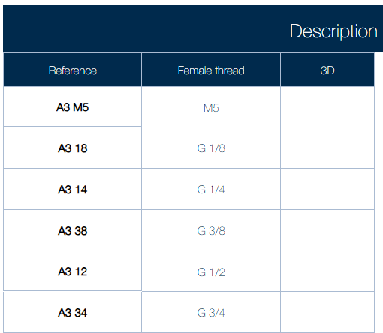

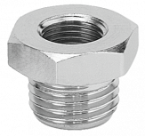
https://www.prevost.eu/parallel-male-female-reducer-a4z-503
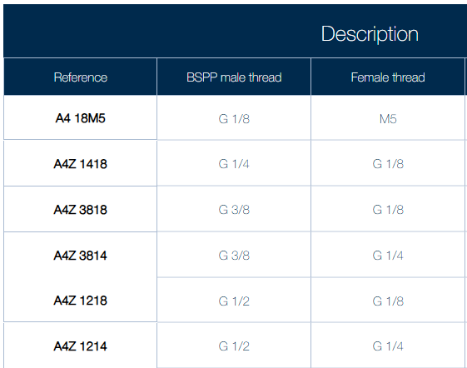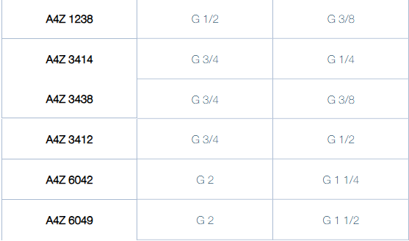
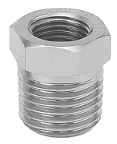
https://www.prevost.eu/tapered-male-parallel-female-reducer-a4-502
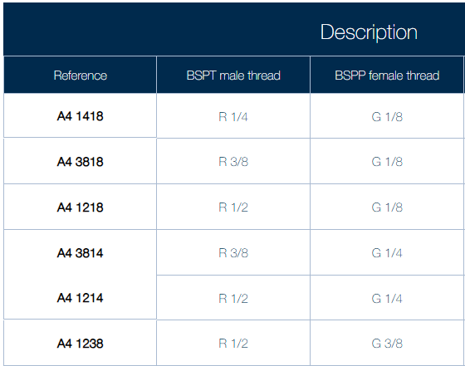
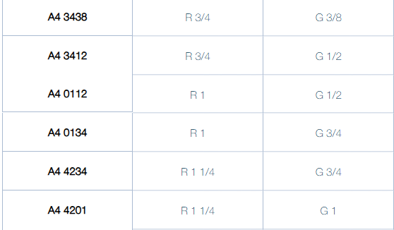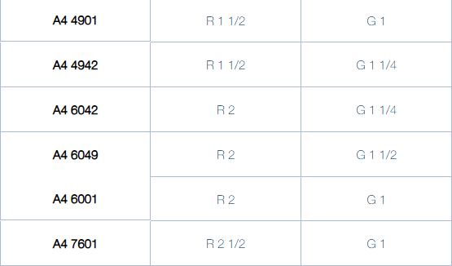

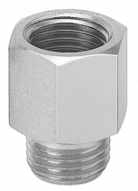
https://www.prevost.eu/parallel-male-female-extender-a5z-505
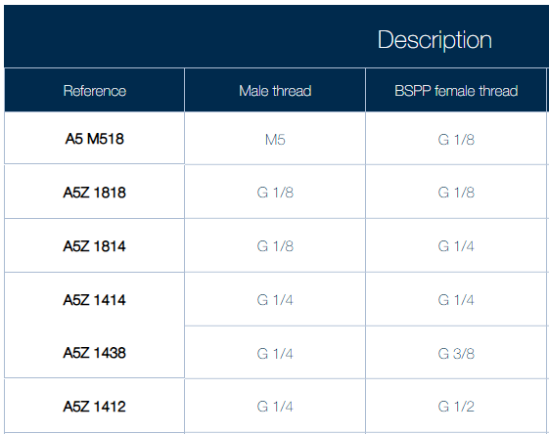
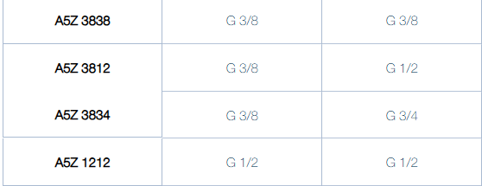

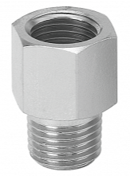
https://www.prevost.eu/male-female-extender-a5-504
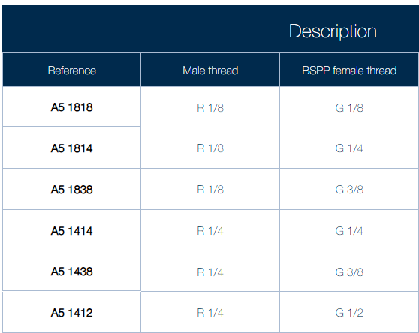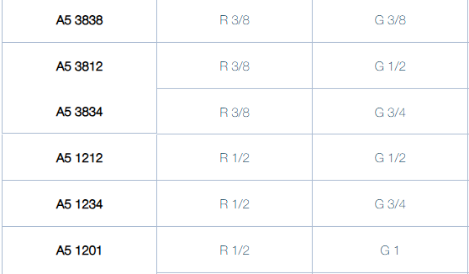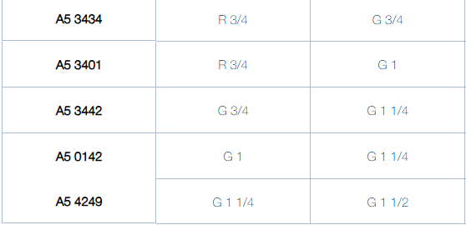

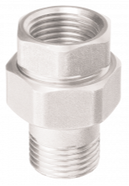
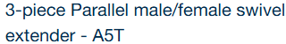
https://www.prevost.eu/3-piece-parallel-male-female-swivel-extender-a5t-506
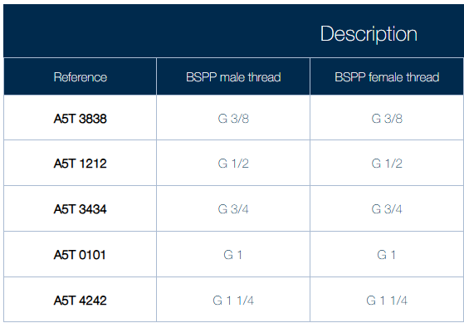
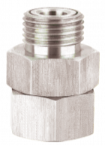
https://www.prevost.eu/parallel-male-female-swivel-fitting-a35-507
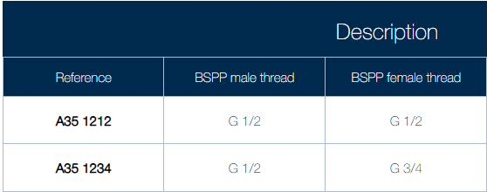
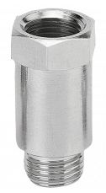
https://www.prevost.eu/parallel-male-female-extender-a5-rl-508
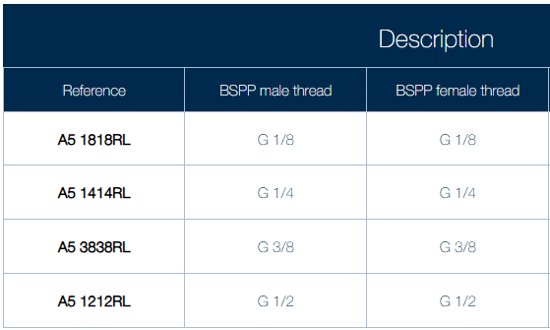

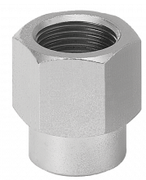
https://www.prevost.eu/parallel-female-female-extender-a6-509
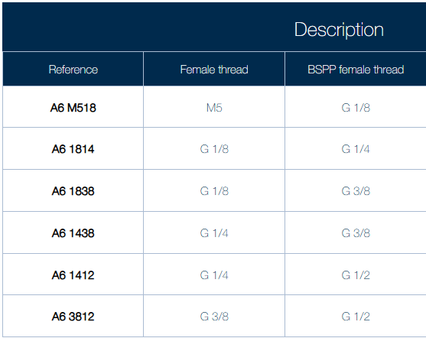

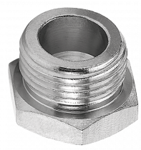
https://www.prevost.eu/parallel-hexagonal-male-plug-a7-510
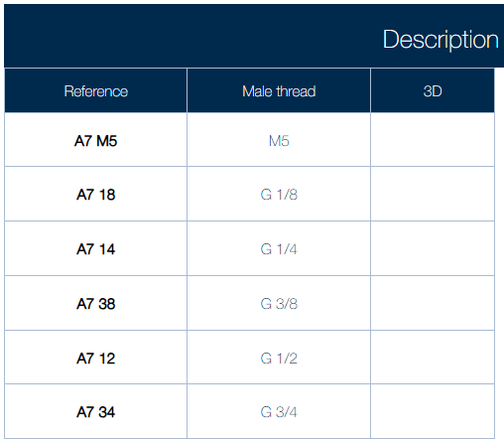

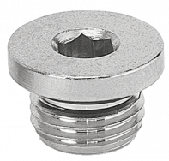
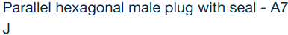
https://www.prevost.eu/parallel-hexagonal-male-plug-seal-a7-j-511
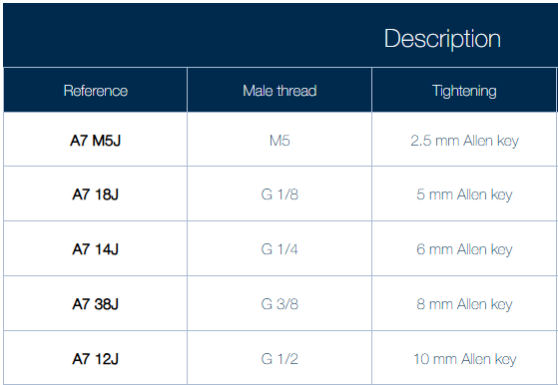

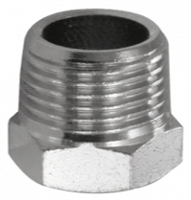
https://www.prevost.eu/tapered-hexagonal-male-plug-a18-512
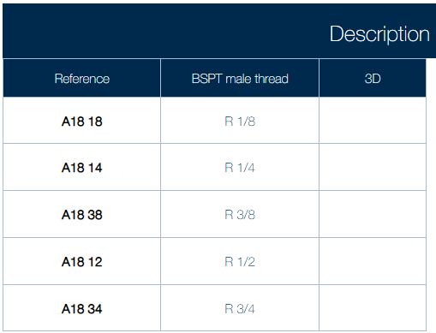

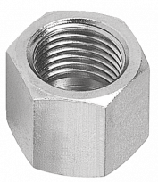
https://www.prevost.eu/female-cap-a8-513
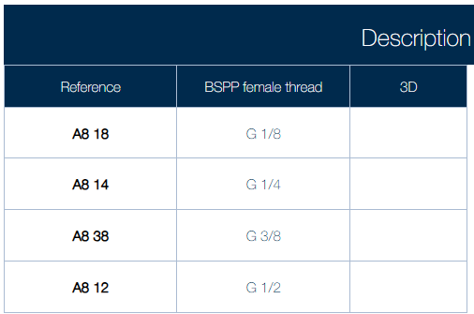

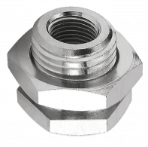
https://www.prevost.eu/female-bulkhead-fitting-a21-515
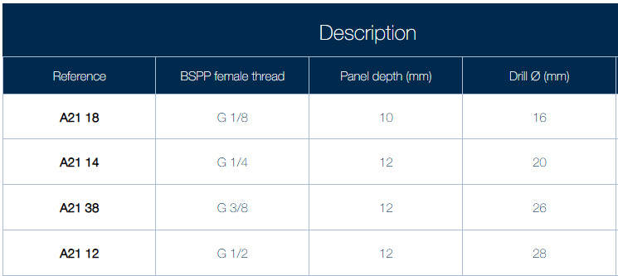

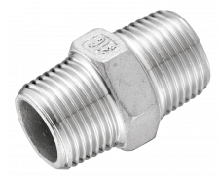
https://www.prevost.eu/equal-tapered-male-union-535
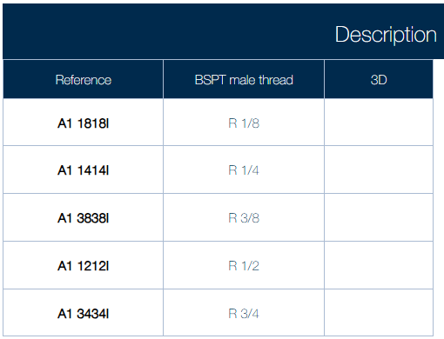

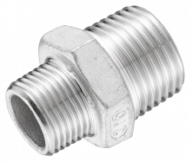
https://www.prevost.eu/unequal-tapered-male-union-536
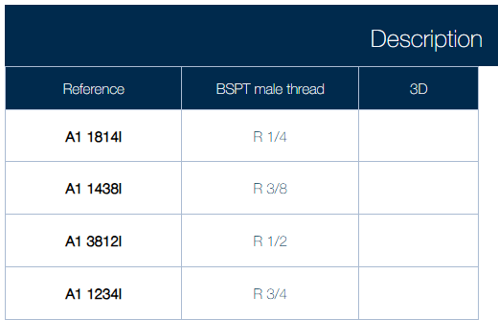

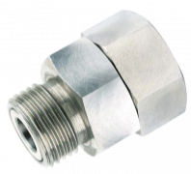
https://www.prevost.eu/swivel-fitting-1788
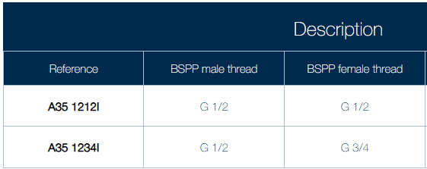

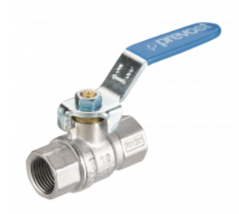
https://www.prevost.eu/connection/valves-2739

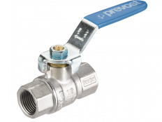
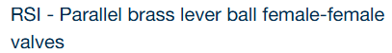
https://www.prevost.eu/rsi-parallel-brass-lever-ball-female-female-valves-470
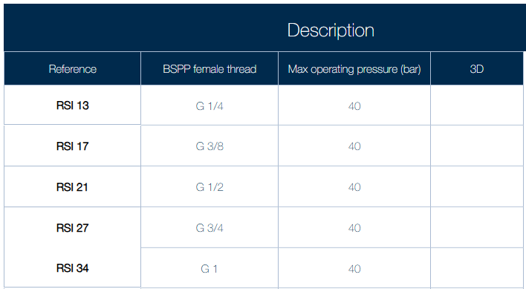

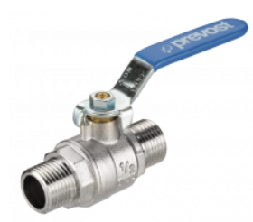
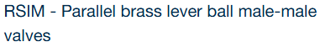
https://www.prevost.eu/rsim-parallel-brass-lever-ball-male-male-valves-471
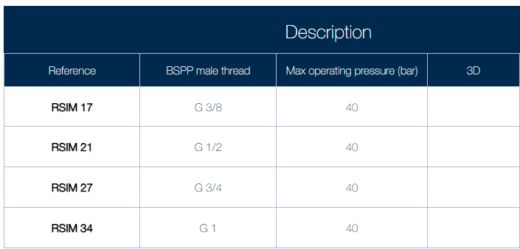

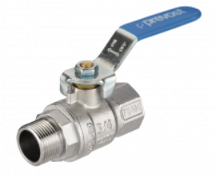
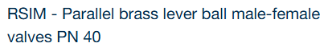
https://www.prevost.eu/rsim-parallel-brass-lever-ball-male-female-valves-pn-40-472
