2.DISTRIBUTION:
https://www.prevost.eu/distribution-1824

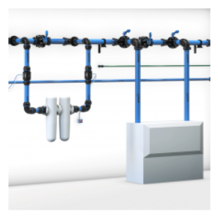
https://www.prevost.eu/distribution/compressed-air-pipe-and-fitting-28

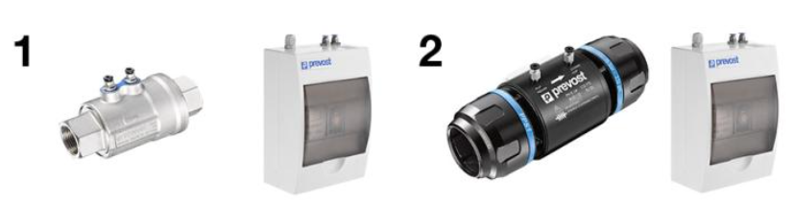
https://www.prevost.eu/pps1-ekitvp-pneumatic-safety-valve-3679

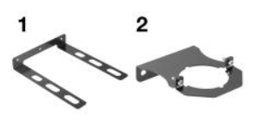
https://www.prevost.eu/product/15142
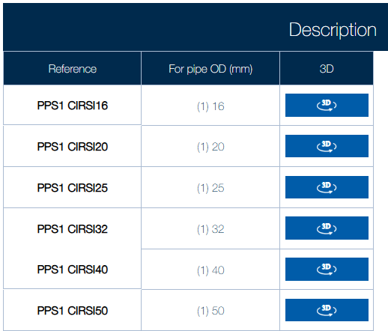

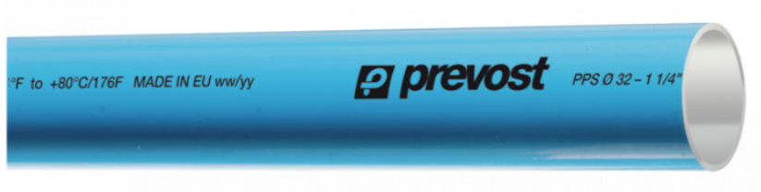
https://www.prevost.eu/pps-aluminium-blue-pipe-compressed-air-3310
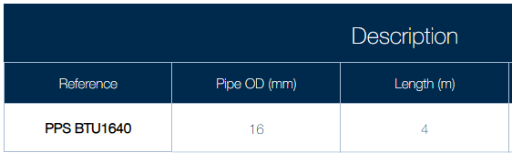

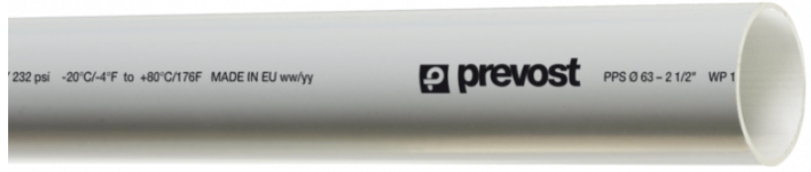
https://www.prevost.eu/pps-aluminium-grey-pipe-vacuum-3311
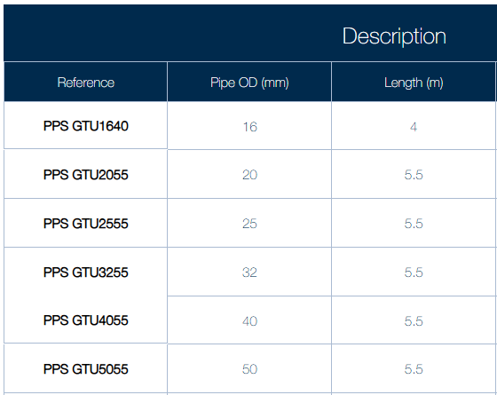
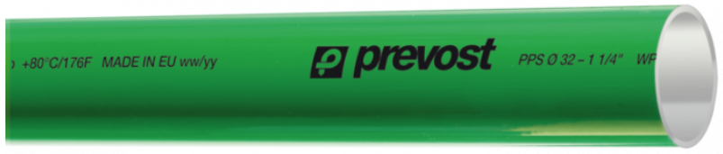
https://www.prevost.eu/pps-aluminium-green-pipe-nitrogen-3312
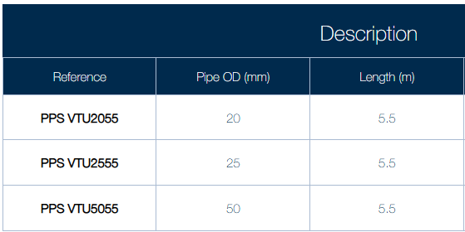

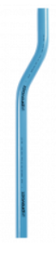
https://www.prevost.eu/pps-aluminium-blue-bended-link-pipe-3313
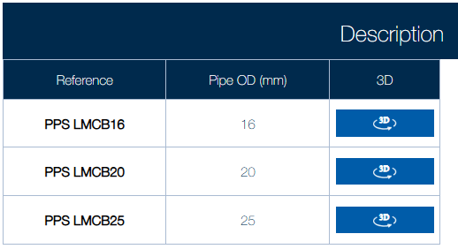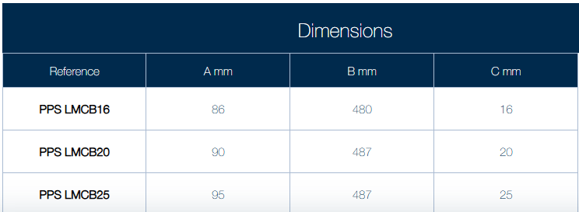
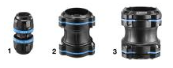
https://www.prevost.eu/pps1-un-aluminium-union-pipe-3288
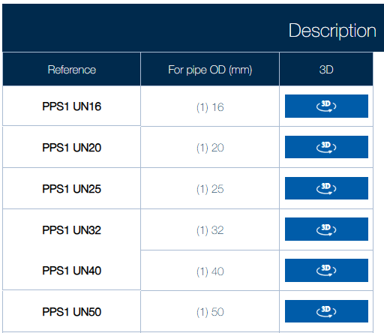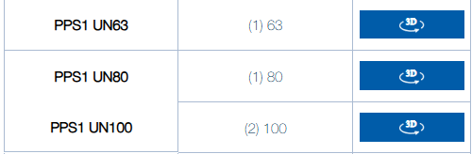
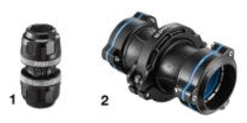
https://www.prevost.eu/pps1-uns-aluminium-female-sliding-union-pipe-3304
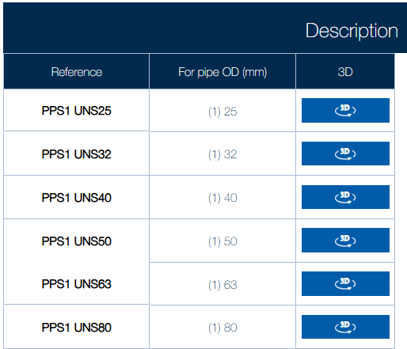

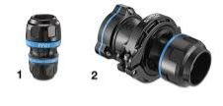
https://www.prevost.eu/pps1-mr-aluminium-pipe-reducing-fitting-3289
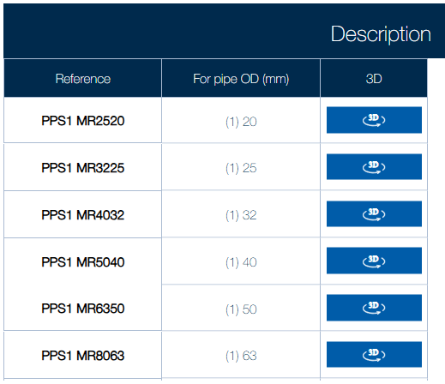

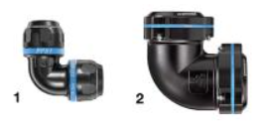
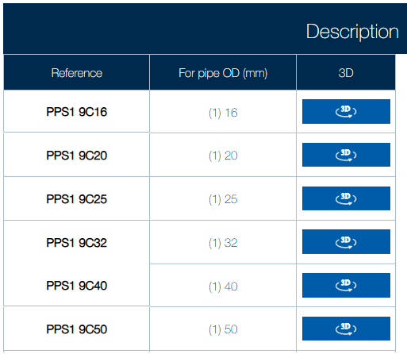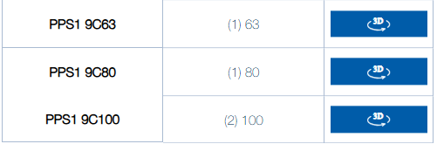
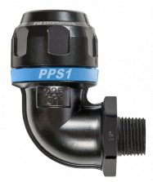
https://www.prevost.eu/pps1-9cm-90degaluminium-tapered-male-thread-elbow-fitting-pipe-3302
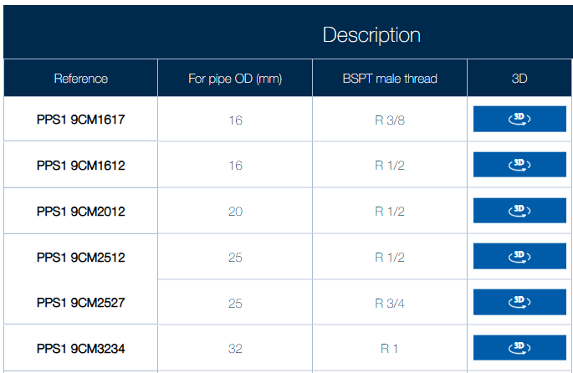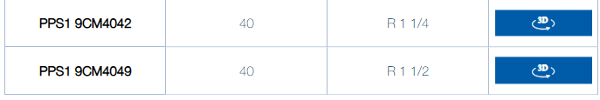
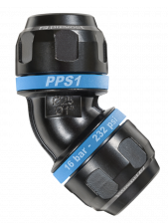
https://www.prevost.eu/pps1-4c-45deg-aluminium-equal-female-elbow-fitting-3292
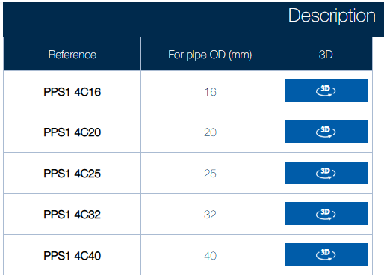

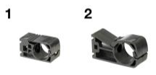

https://www.prevost.eu/pps1-ci-pipe-clamp-3296
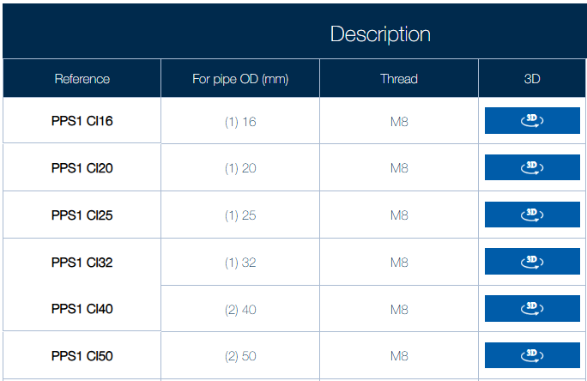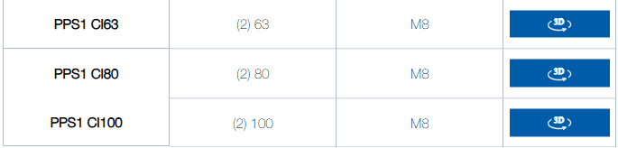
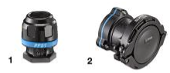
https://www.prevost.eu/pps1-bo-aluminium-female-cap-pipe-3291
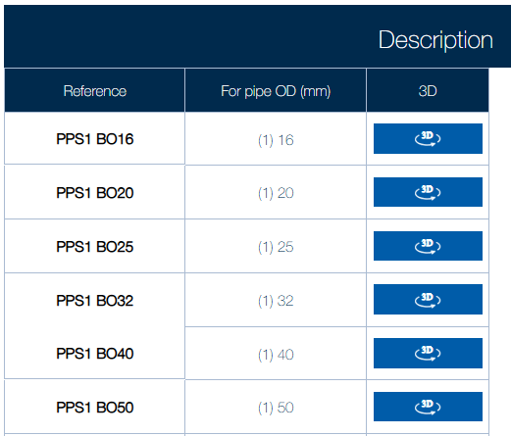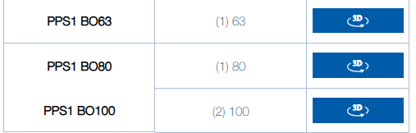
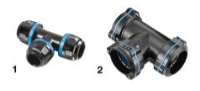
https://www.prevost.eu/pps1-te-aluminium-equal-female-tee-fitting-pipe-3293
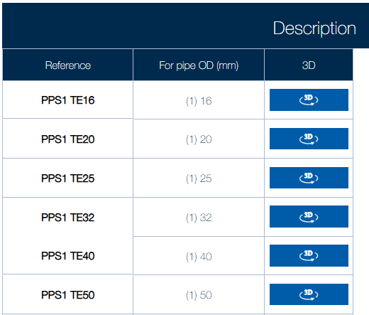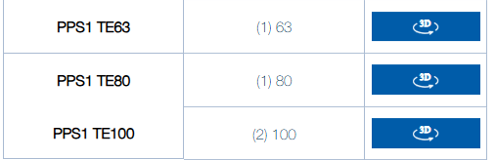
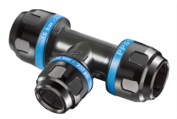
https://www.prevost.eu/pps1-tr-aluminium-reducing-tee-fitting-3294

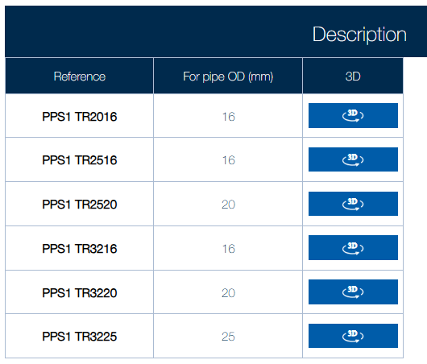
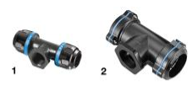
https://www.prevost.eu/pps1-tt-aluminium-parallel-female-thread-tee-fitting-pipe-3295
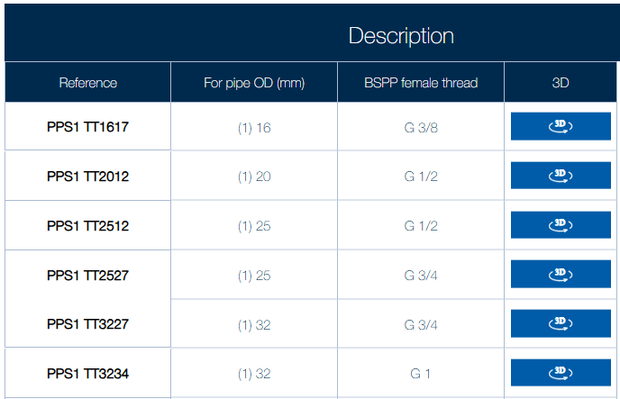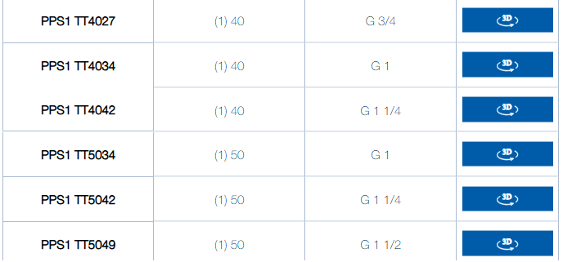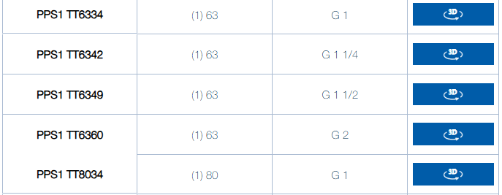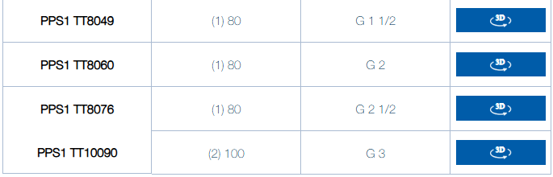

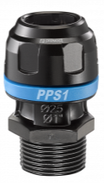
https://www.prevost.eu/pps1-mm-aluminium-tapered-male-thread-straight-fitting-pipe-3285
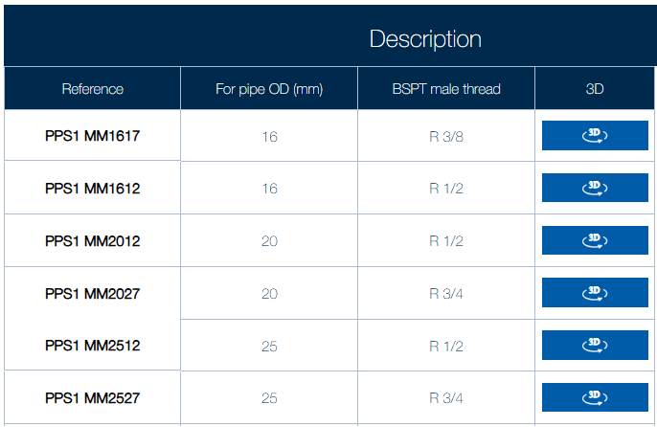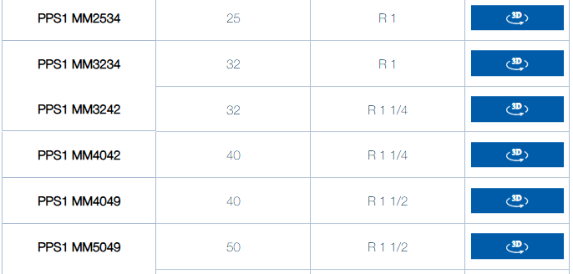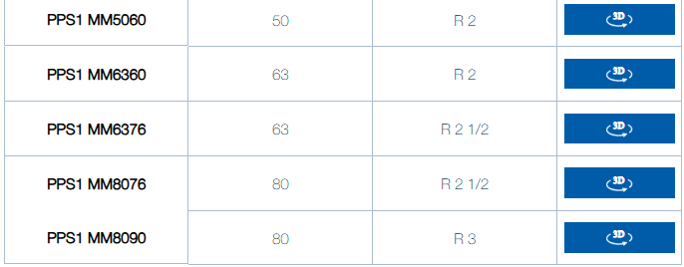
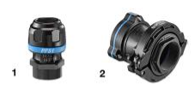
https://www.prevost.eu/pps1-mf-aluminium-female-thread-straight-fitting-pipe-3303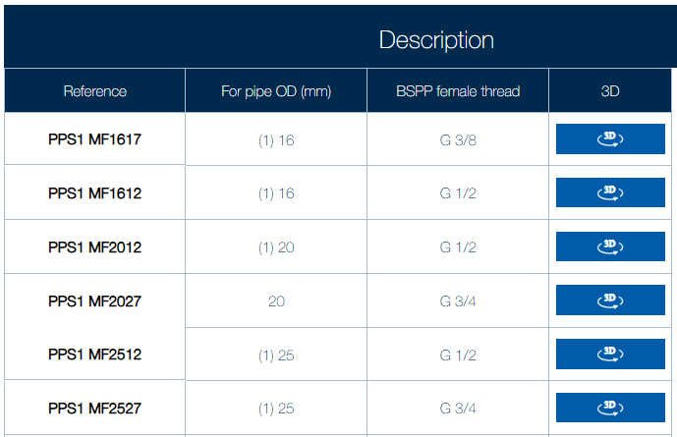 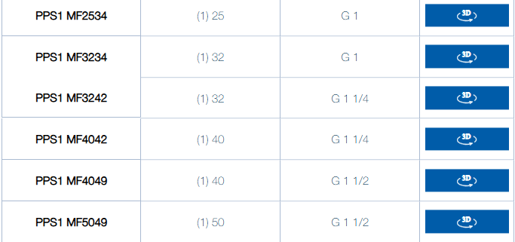 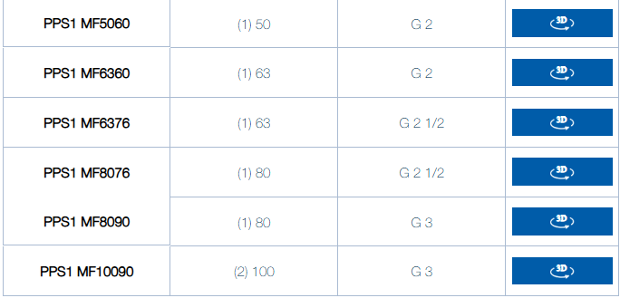

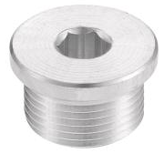
https://www.prevost.eu/pps1-a7-aluminum-cap-cross-fitting-3597
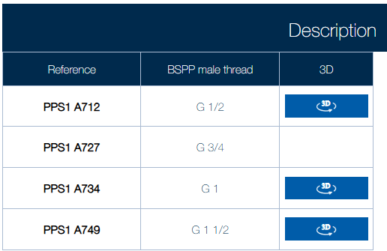

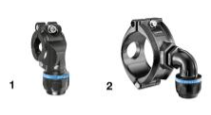
https://www.prevost.eu/pps1-bp-aluminium-tapping-flange-pipe-3298
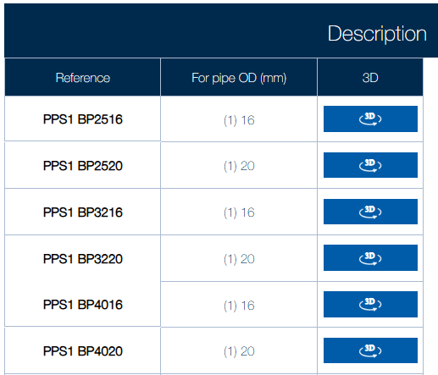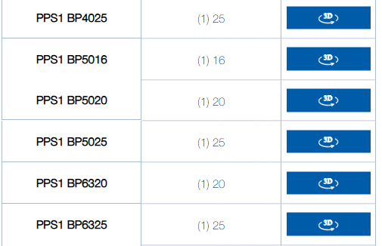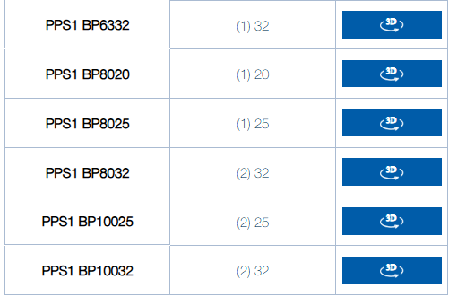

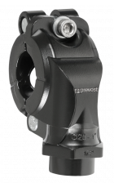
https://www.prevost.eu/pps1-bt-aluminium-female-thread-tapping-flange-3299
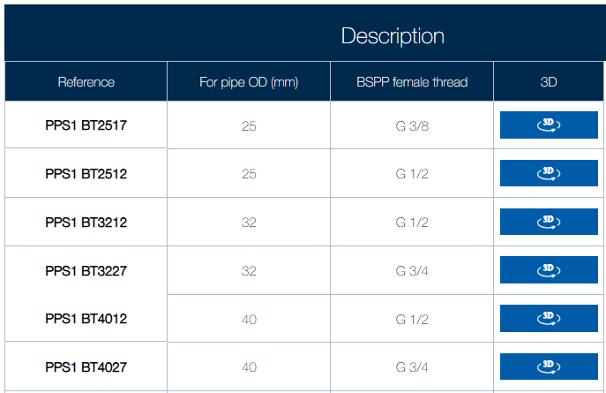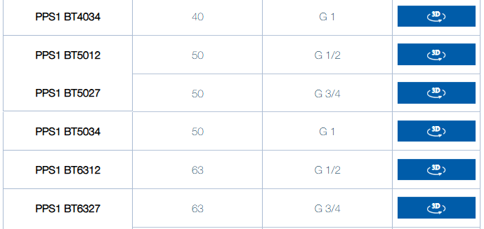
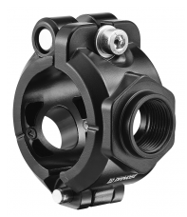
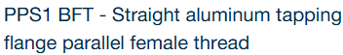
https://www.prevost.eu/pps1-bft-straight-aluminum-tapping-flange-parallel-female-thread-3570
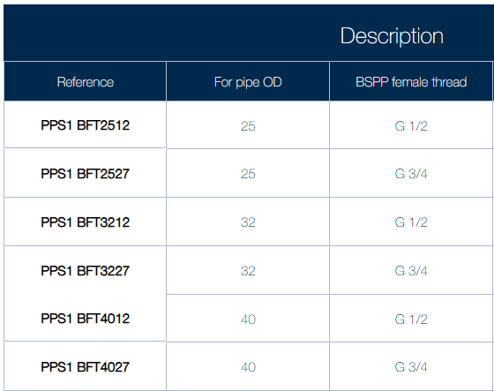
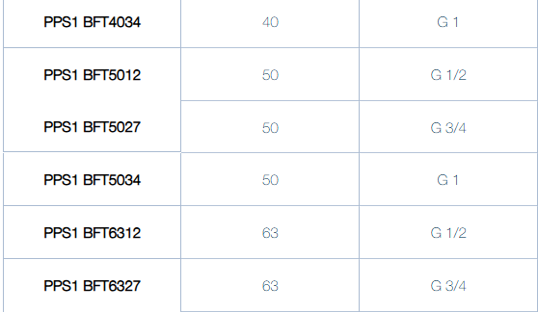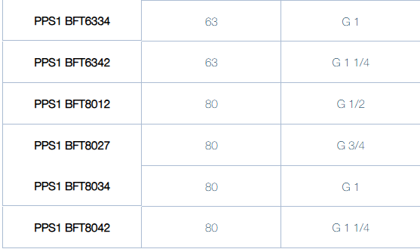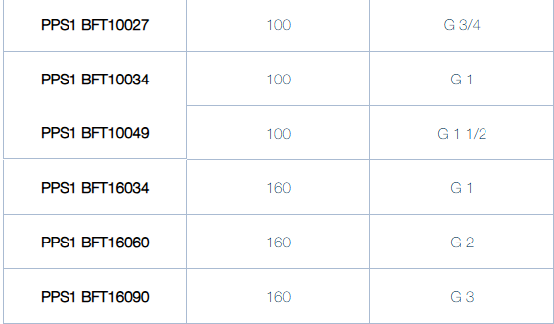

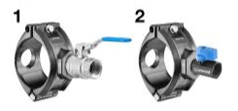
https://www.prevost.eu/pps1-bfv-tapping-flange-bft-valve-3580
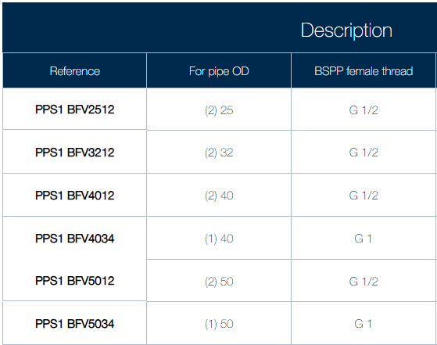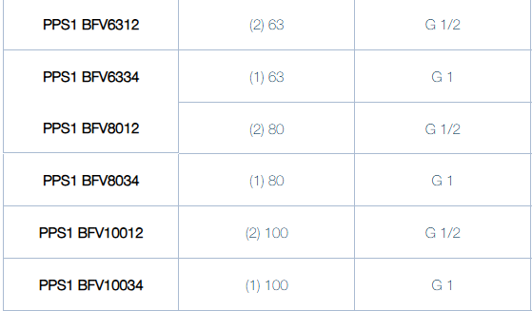

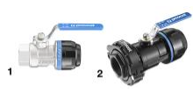
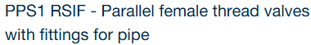
https://www.prevost.eu/product/13842
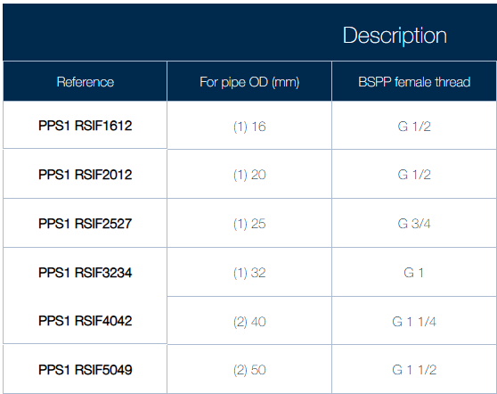
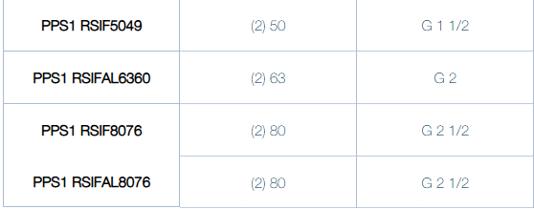
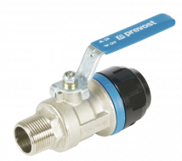
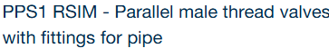
https://www.prevost.eu/pps1-rsim-parallel-male-thread-valves-fittings-pipe-3307
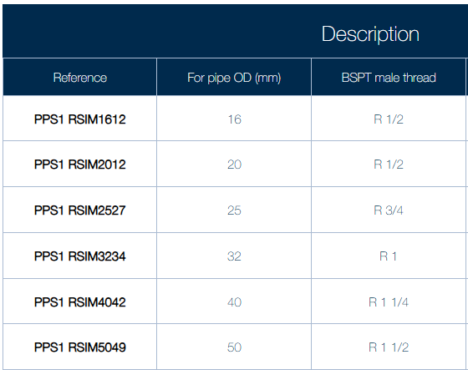
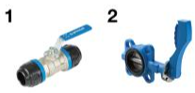
https://www.prevost.eu/pps1-rsi-piping-valve-3305
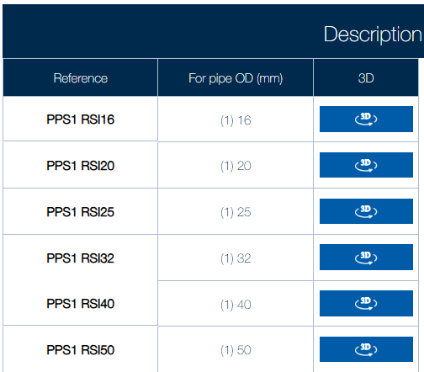
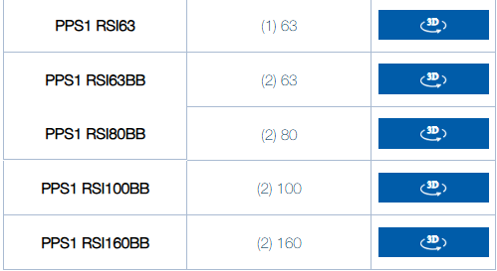

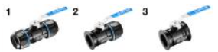
https://www.prevost.eu/pps1-rsi-al-aluminum-body-valve-3596
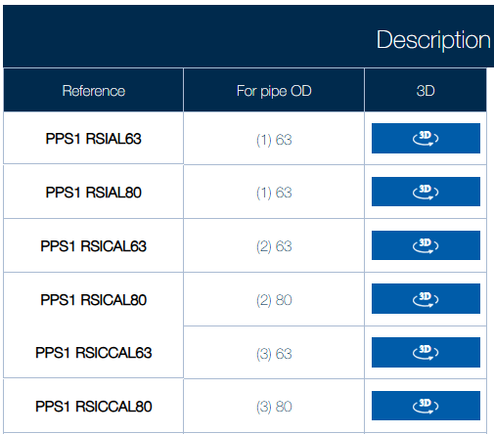
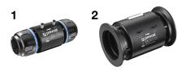
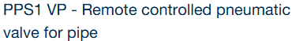
https://www.prevost.eu/pps1-vp-remote-controlled-pneumatic-valve-pipe-3582
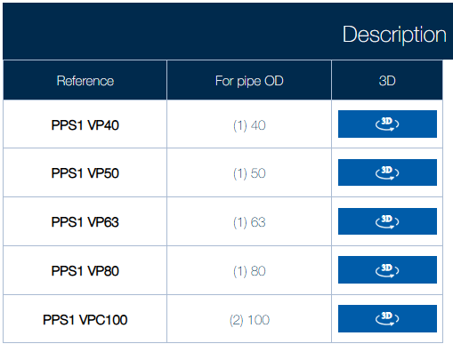

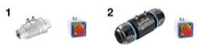
https://www.prevost.eu/product/17677
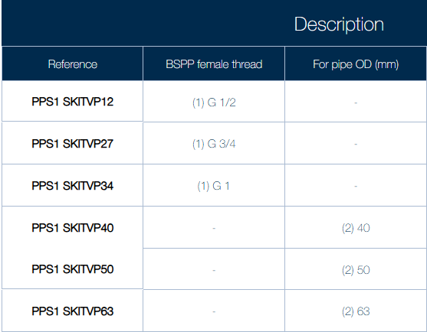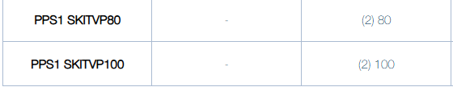

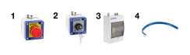

https://www.prevost.eu/pps-rp-remote-control-valve-pps1-vp-3588
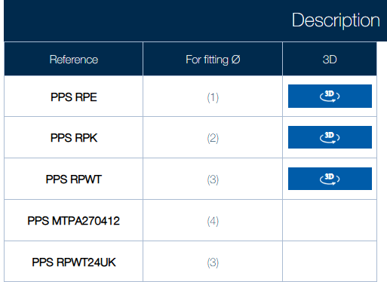

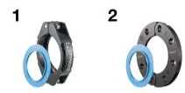
https://www.prevost.eu/pps1-cc-concept-connecting-parts-3591
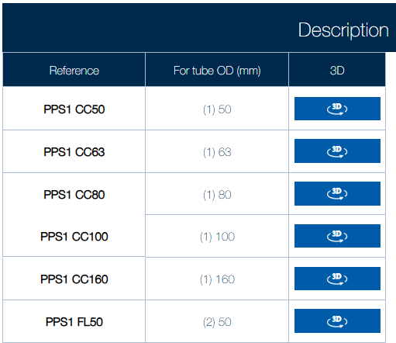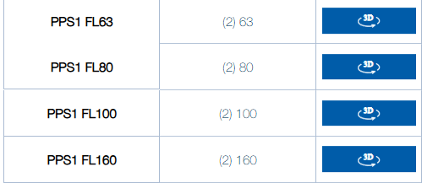

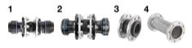
https://www.prevost.eu/pps1-dk-expansion-kit-3440
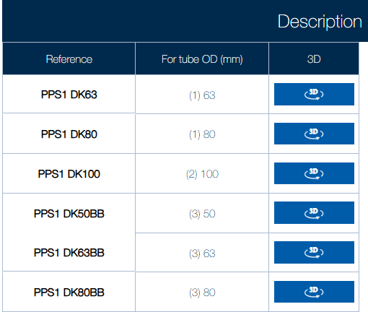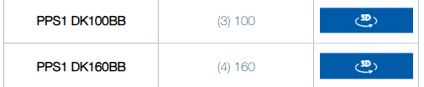

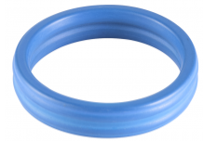
https://www.prevost.eu/product/14260
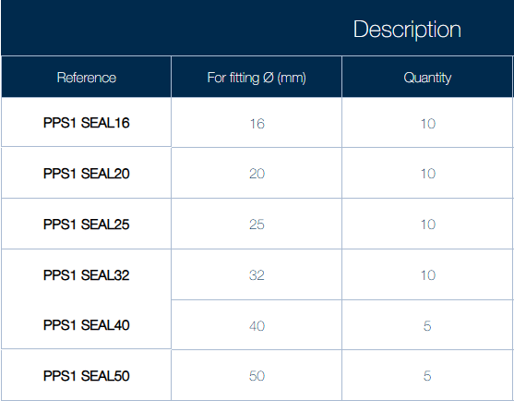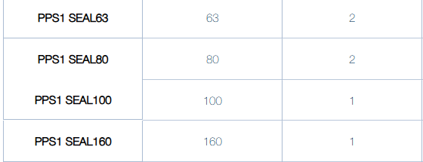

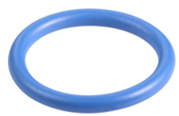
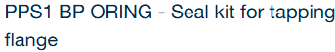
https://www.prevost.eu/pps1-bp-oring-seal-kit-tapping-flange-3573
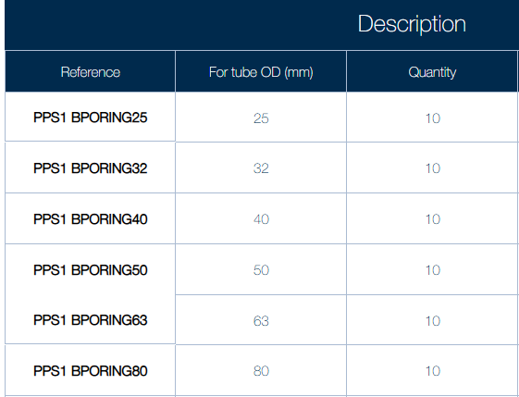

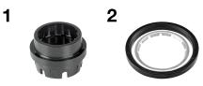
https://www.prevost.eu/pps1-ip-internal-parts-kit-3309
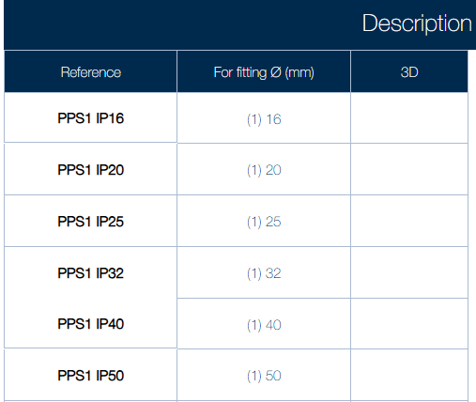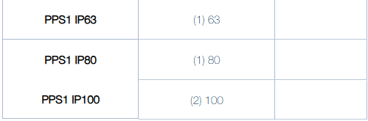

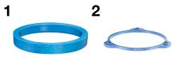
https://www.prevost.eu/pps1-ba-band-kit-10-3424
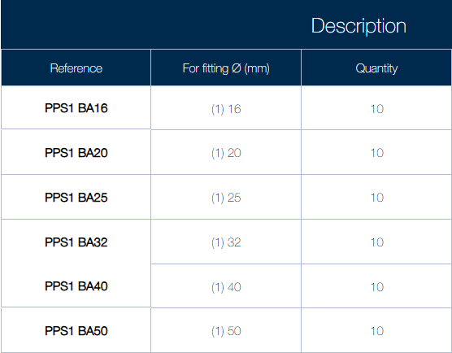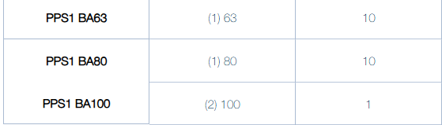

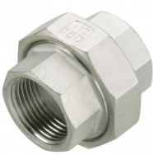
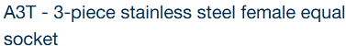
https://www.prevost.eu/a3t-3-piece-stainless-steel-female-equal-socket-753
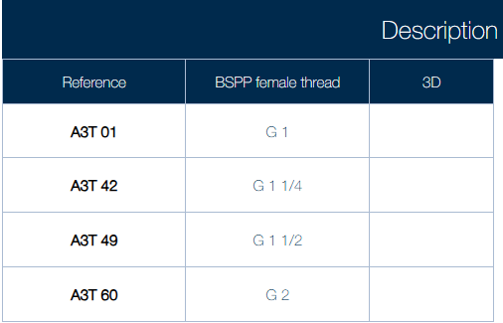

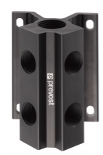
https://www.prevost.eu/manifold-3438
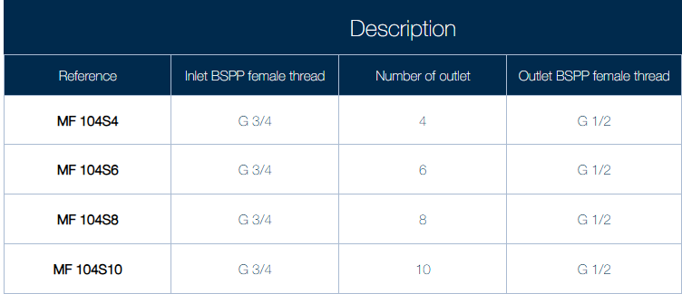

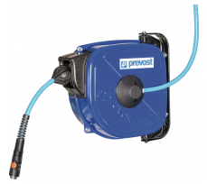
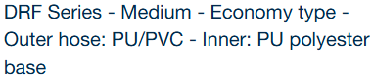
https://www.prevost.eu/drf-series-medium-economy-type-outer-hose-pu-pvc-inner-pu-polyester-base-1397
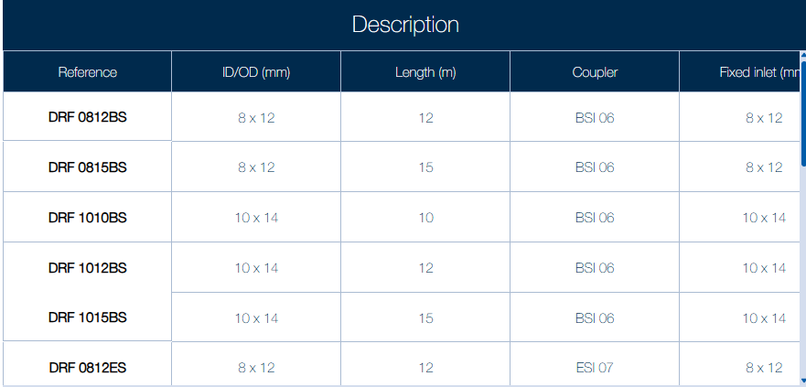
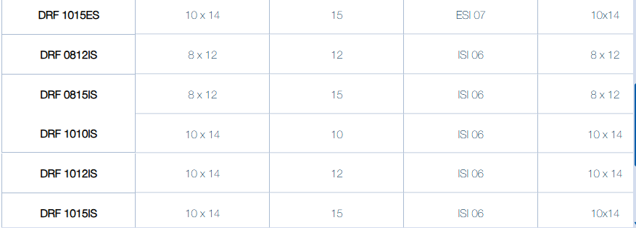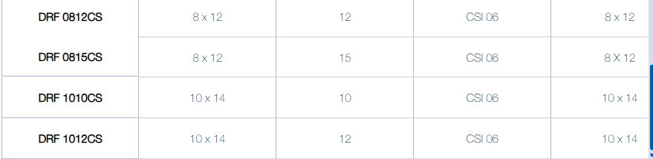

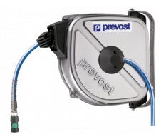
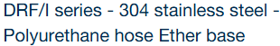
https://www.prevost.eu/drf-i-series-304-stainless-steel-polyurethane-hose-ether-base-1895
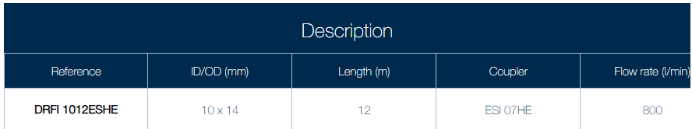
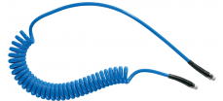
https://www.prevost.eu/distribution/spiral-hose-extension-3273

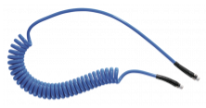
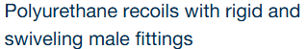
https://www.prevost.eu/polyurethane-recoils-rigid-and-swiveling-male-fittings-632
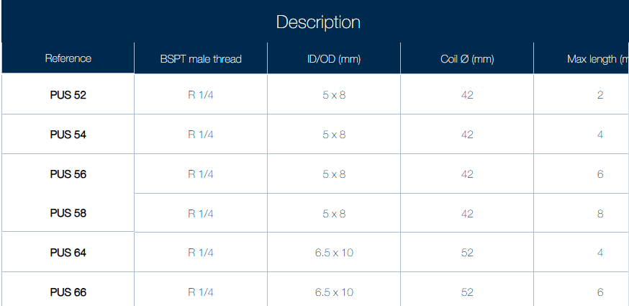



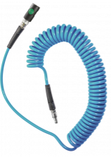
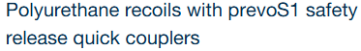
https://www.prevost.eu/polyurethane-recoils-prevos1-safety-release-quick-couplers-1555
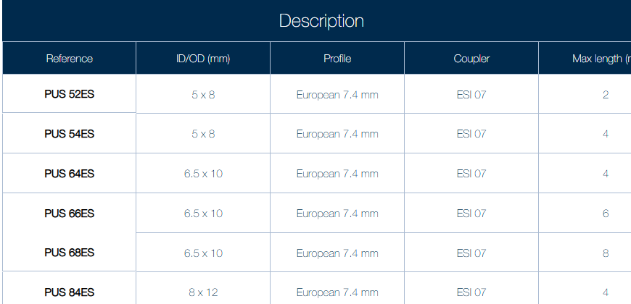

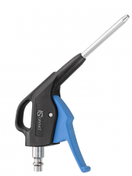
https://www.prevost.eu/distribution/blow-guns-77
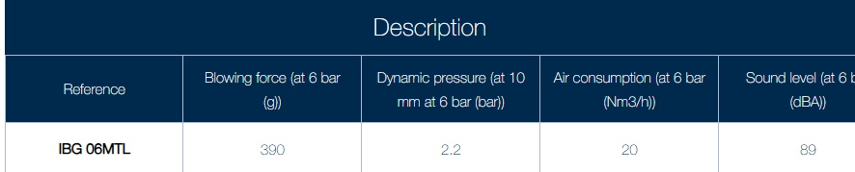

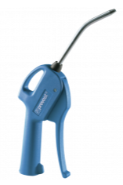
https://www.prevost.eu/blow-gun-metal-nozzle-575
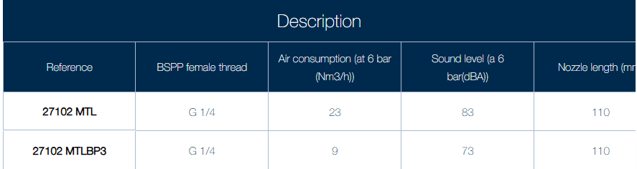

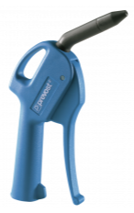
https://www.prevost.eu/blow-gun-composite-nozzle-576
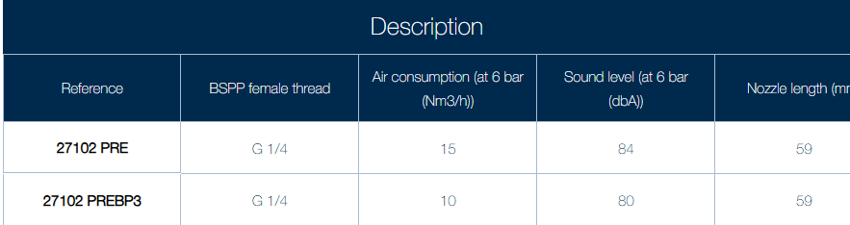

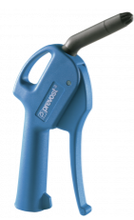
https://www.prevost.eu/blow-gun-silent-nozzle-577
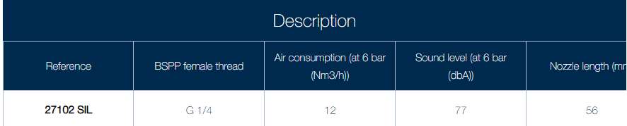

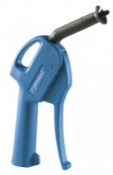
https://www.prevost.eu/blow-gun-protective-air-curtain-578
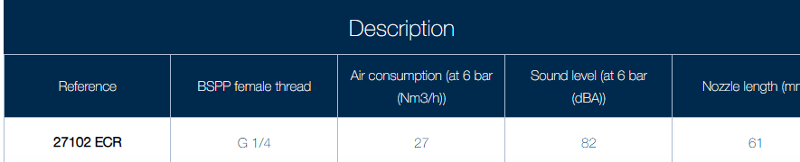

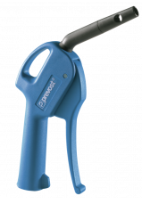
https://www.prevost.eu/blow-gun-osha-venturi-effect-579
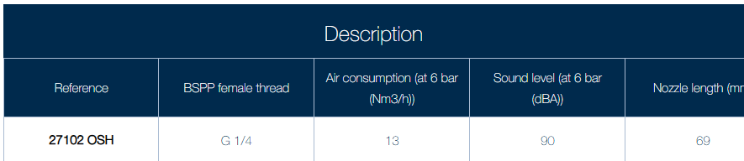

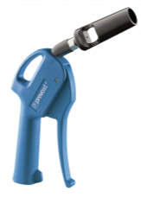
https://www.prevost.eu/blow-gun-venturi-effect-3518
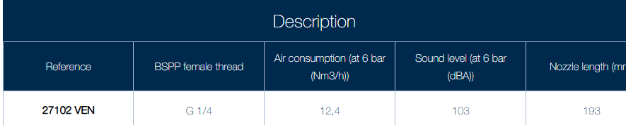

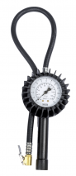
https://www.prevost.eu/distribution/tyre-inflators-87
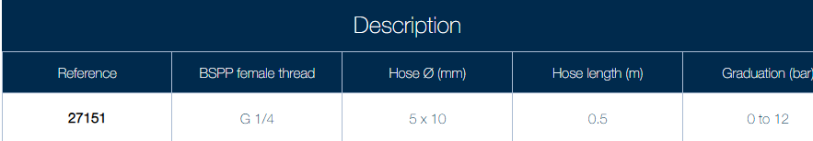


https://www.prevost.eu/distribution/compressed-air-tools-2435
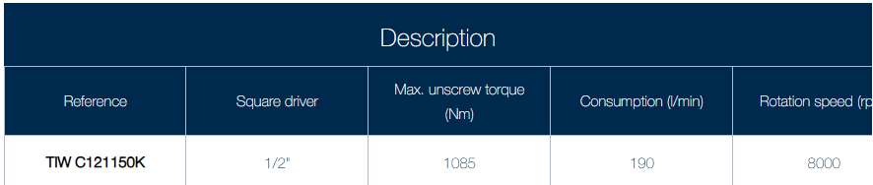

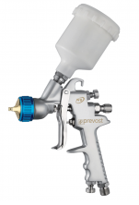
https://www.prevost.eu/distribution/paintwork-1859

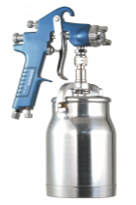

https://www.prevost.eu/suction-feed-spray-gun-technical-spray-painting-624
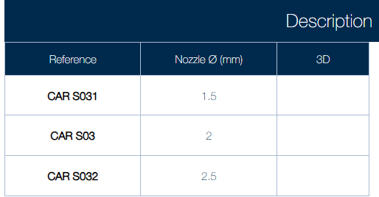

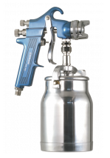

https://www.prevost.eu/suction-feed-spray-gun-industrial-spray-painting-625
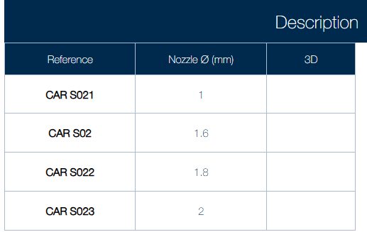

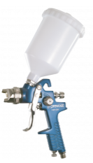
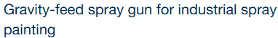
https://www.prevost.eu/gravity-feed-spray-gun-industrial-spray-painting-626
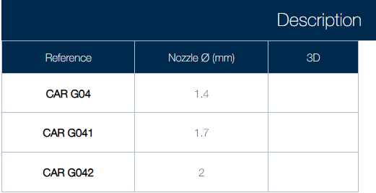

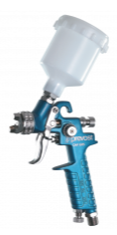
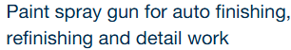
https://www.prevost.eu/paint-spray-gun-auto-finishing-refinishing-and-detail-work-627
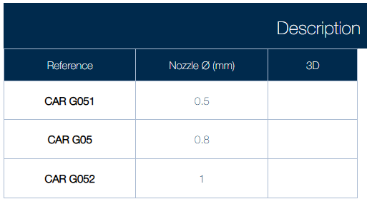

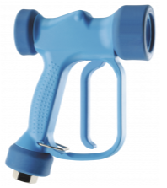
https://www.prevost.eu/industrial-wash-gun-908
